**HomeWork#1**

20191128 Jian Park

**Environment :**

|  |  |  |  |
| --- | --- | --- | --- |
| **Hardware** | **OS** | **Wireshark Version** | **Network** |
| MacBook Pro (16-inch, 2019)  2.3GHz 8-core Intel Core i9  16GB 2667 MHz DDR4  Intel UHD Graphics 630 1536MB | macOS Big Sur (11.6) | 3.4.9 | Wi-Fi  (192.168.0.10) |

**Application1 [Web]**

1. **Naver (www.naver.com)**

***How to create traffic?***

: Use ‘Chrome’. To prevent redirects, delete the cache and connect via ‘http://’.

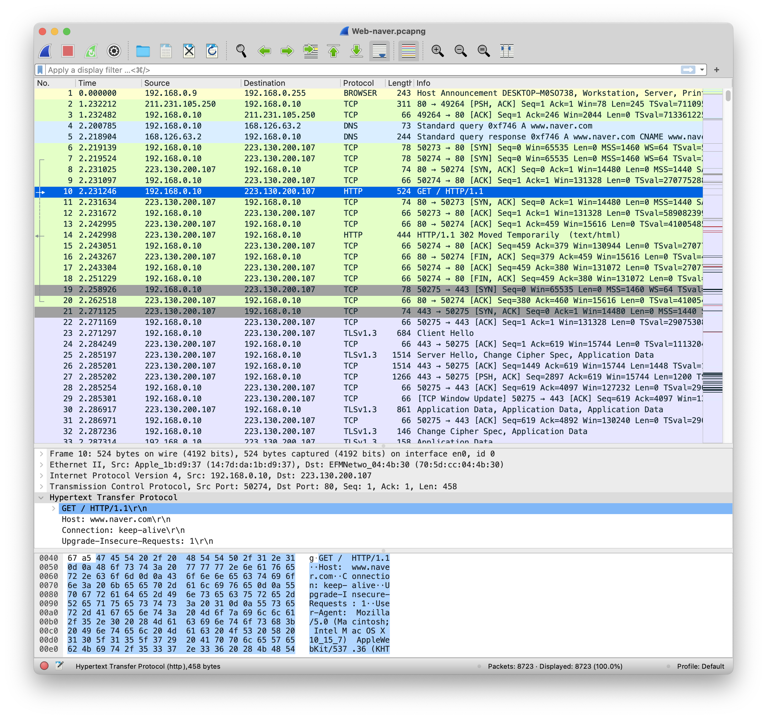 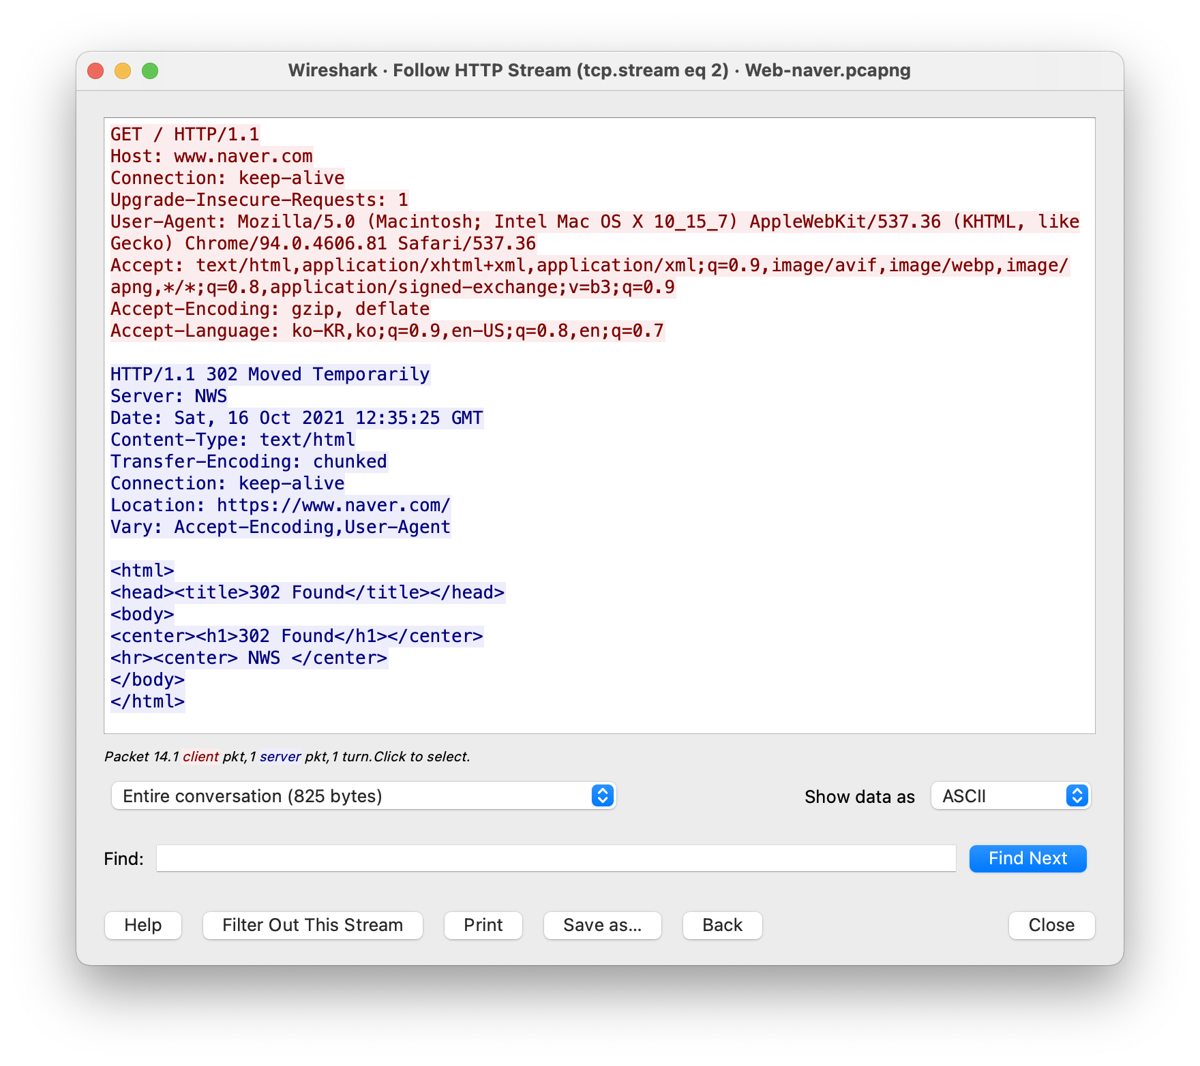

Through this, we can see that HTTP client on port 50274 initiates TCP connection to HTTP server at [www.naver.com](http://www.naver.com) on port 80. (Send SYN) And HTTP server send SYN+ACK to accepts TCP connection.

Through HTTP Request, Response message, HTTP version is HTTP/1.1. In message, ‘Connect’ is ‘keep-alive’ so thie is persistent HTTP.

Through HTTP Request message, we can see

1. user-agent (OS, browser) information : Mozilla/5.0 (Macintosh), Chrome (and also safari, because I had opened safari web)
2. Use method : GET
3. Host address: www.naver.com etc.

Through HTTP Response message, we can see

1. Contect-Type (response message type ) : text/html
2. State code : 302 -> it means to move to Location (https://www.naver.com) . Because http is not safty.

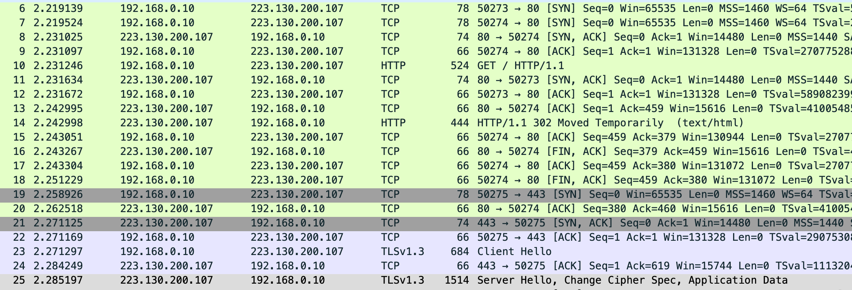 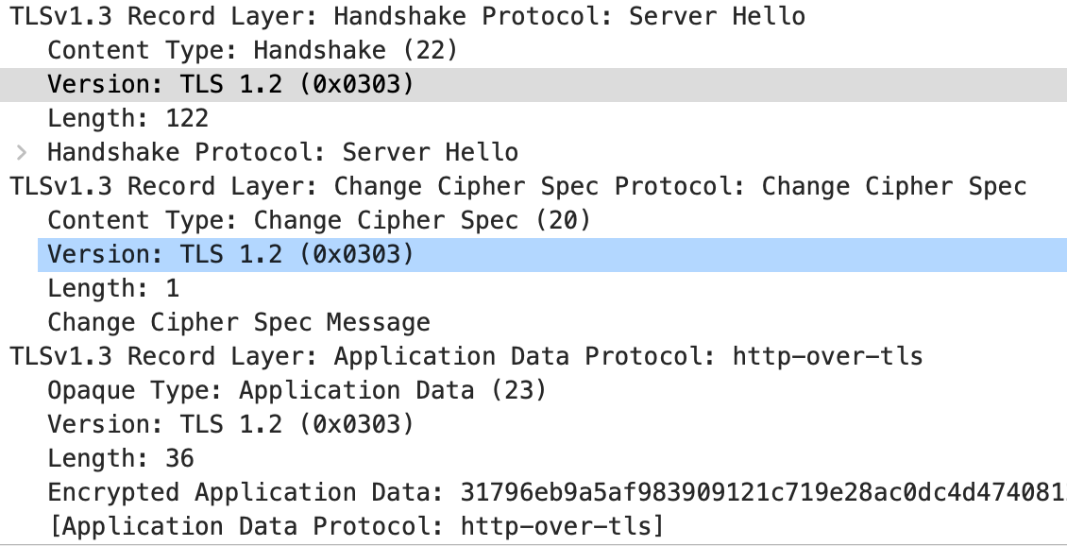

The picture above shows the process of terminating HTTP connection (TCP) and initializing HTTPS connection (TCP with TLS).

HTTPS client on port 50275 initiates TLS connection to HTTPS server at [www.naver.com](http://www.naver.com) on port 443.

For connect HTTPS, also need hand shaking, But this have security process.

1. Client Hello : send TLS version and security algorithm that browser supported. And make random value for encryption.
2. Sever Hello : send TLS version and security algorithm that Using. And also make random value.

In this, Using TLS 1.2.

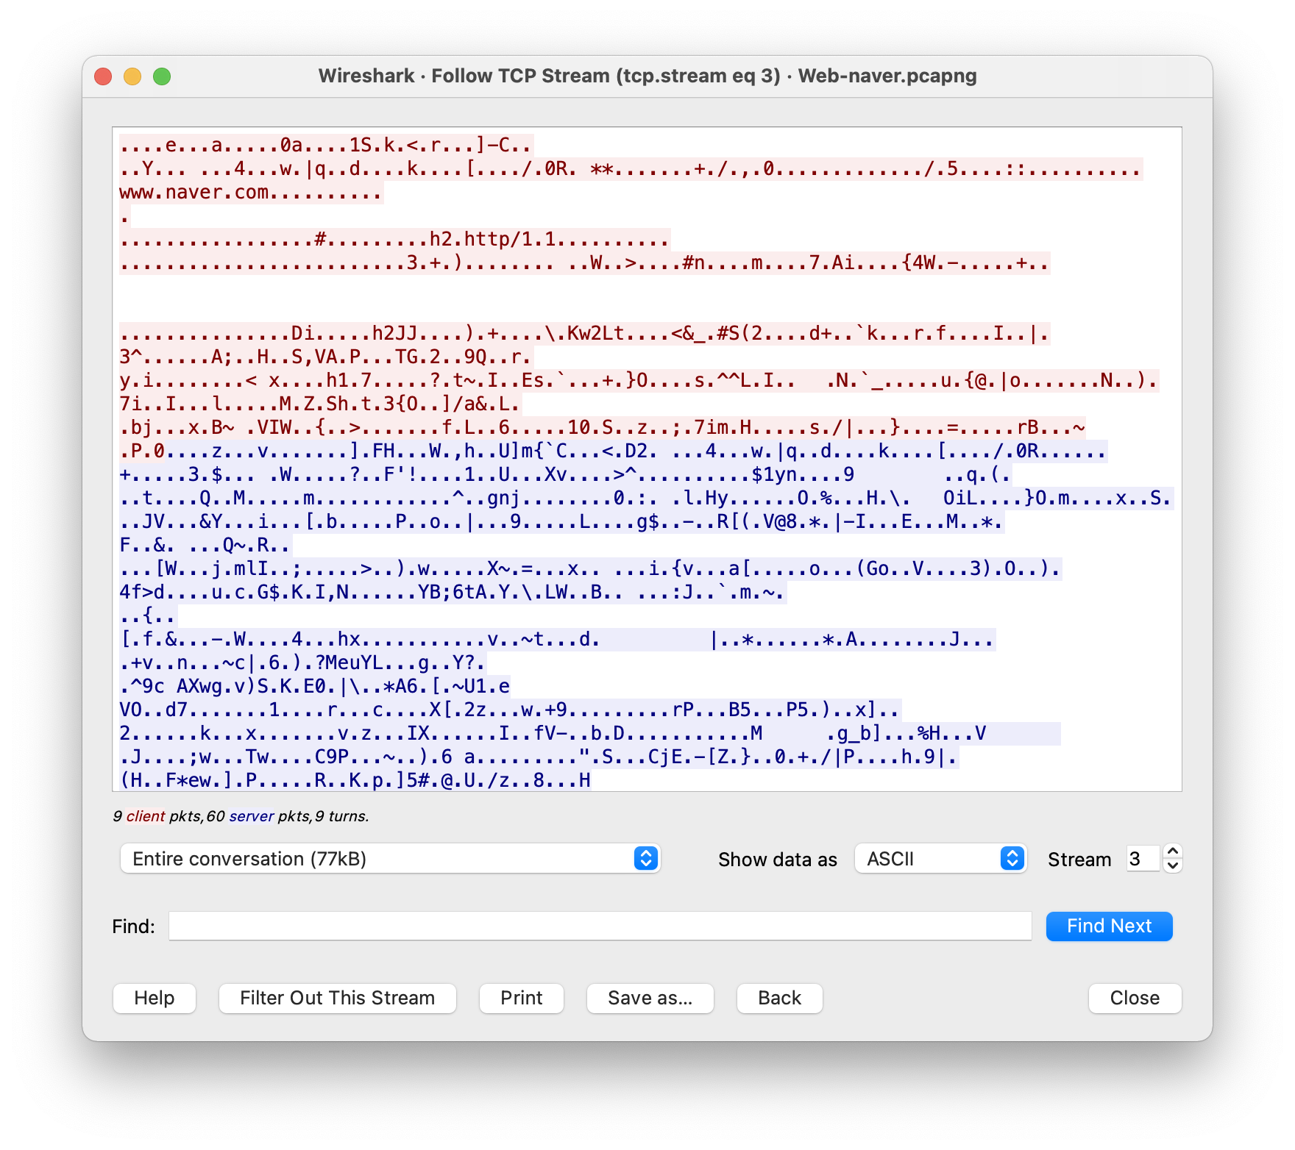

In TLS, we can’t see the request, response message

1. **Httpbin (HTTP testing web,** [**http://httpbin.org**](http://httpbin.org)**)**

***How to create traffic?***

: Use ‘Safari’. I have sent 3 different request message (Post text, Get png, Get json)

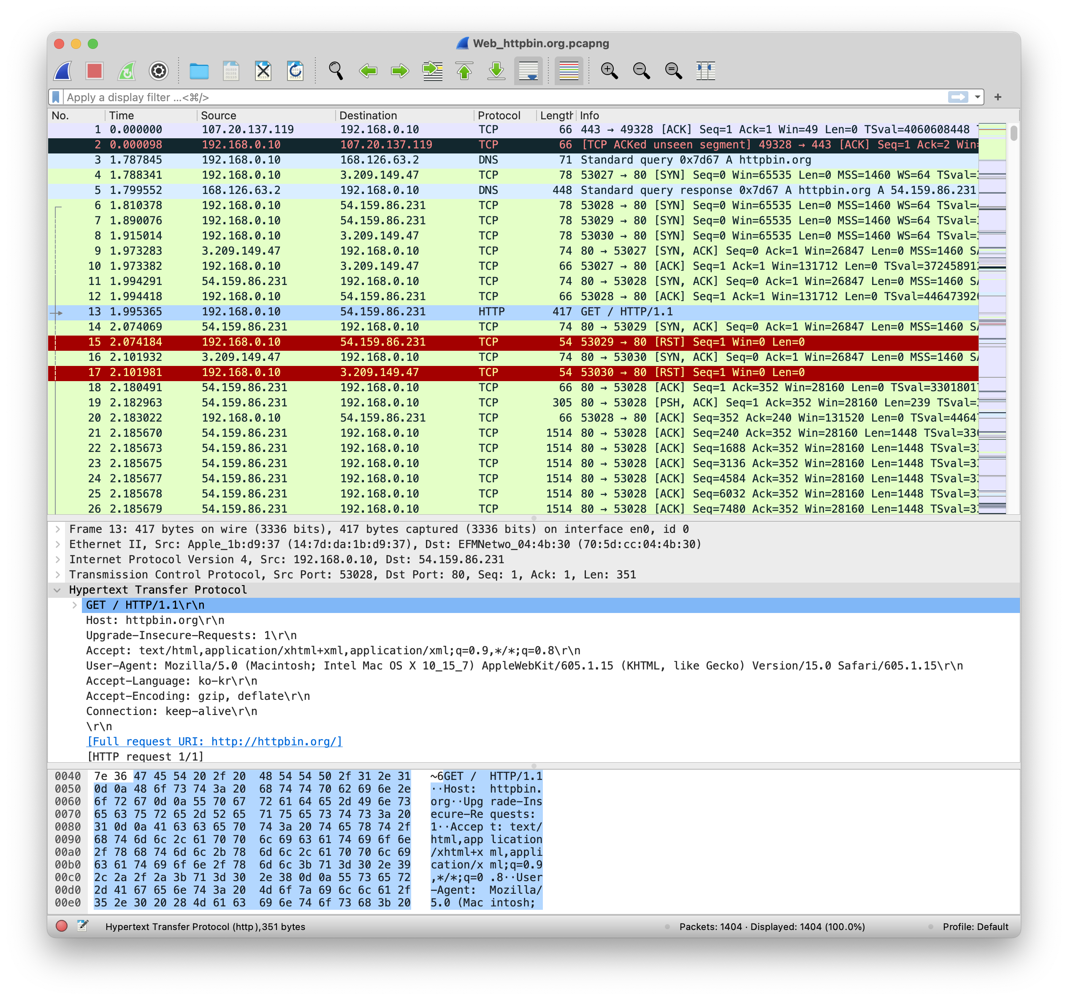 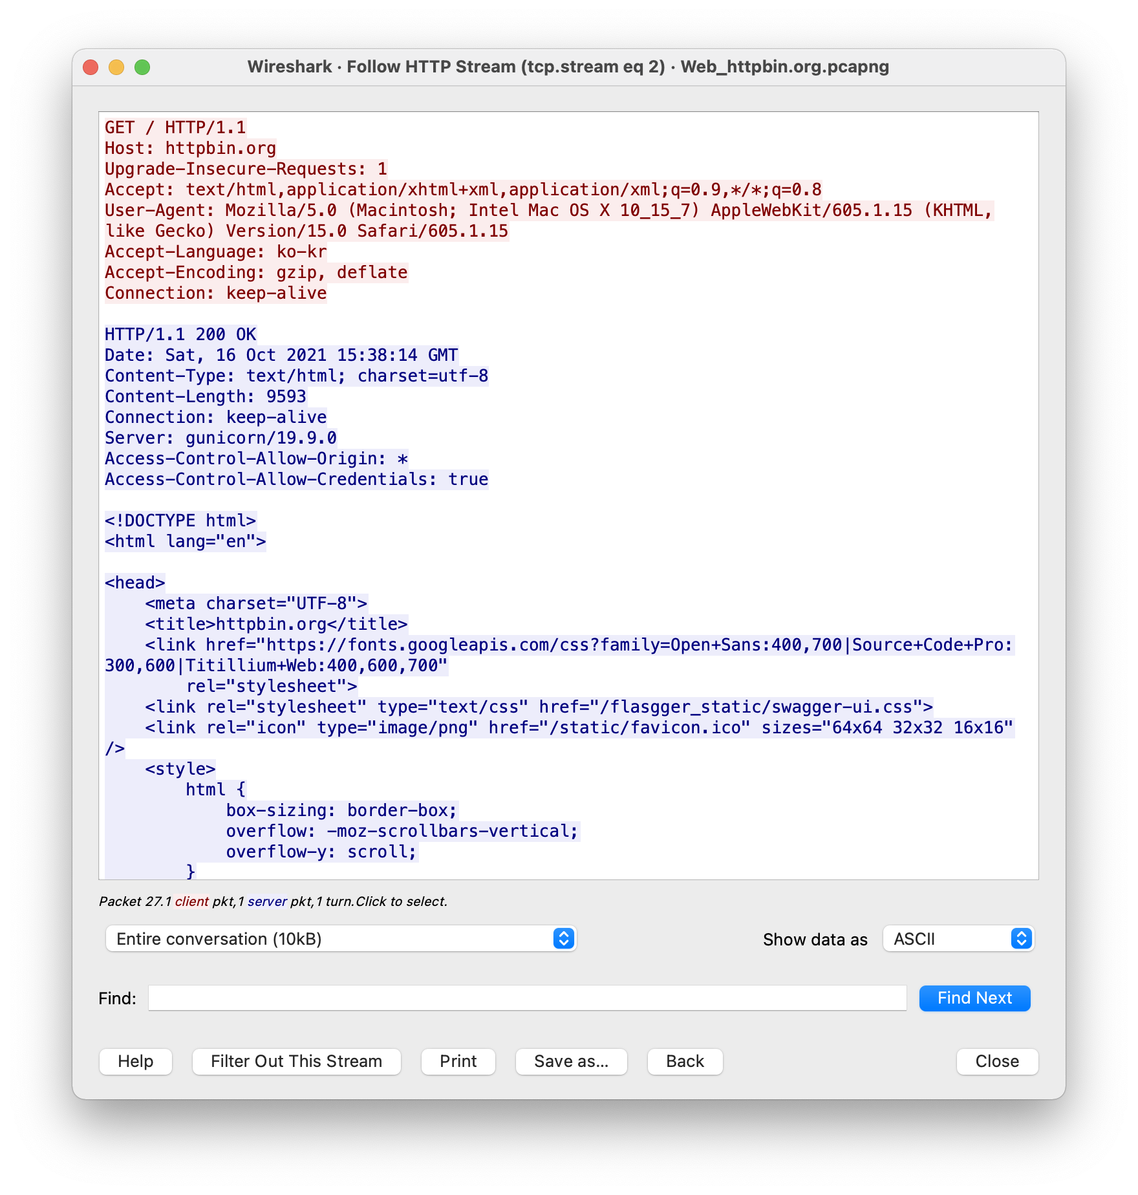

Through this, we can see that HTTP client on port 53028 initiates TCP connection to HTTP server at httpbin.org on port 80. (Send SYN) And HTTP server send SYN+ACK to accepts TCP connection.

Through HTTP Request, Response message, HTTP version is HTTP/1.1. In message, ‘Connect’ is ‘keep-alive’ so thie is persistent HTTP.

Through HTTP Request message, we can see

1. User-agent (OS, browser) information : Mozilla/5.0 (Macintosh), Safari
2. Use method : GET
3. Host address: httpbin.org etc.

Through HTTP Response message, we can see

1. Contect-Type (response message type ) : text/html, charset=utp-8
2. State code : 200-> it means OK.
3. Content-Length (response body length) : 9593
4. Server: gunicorn/19.9.0 etc,
5. ***Post input text data***

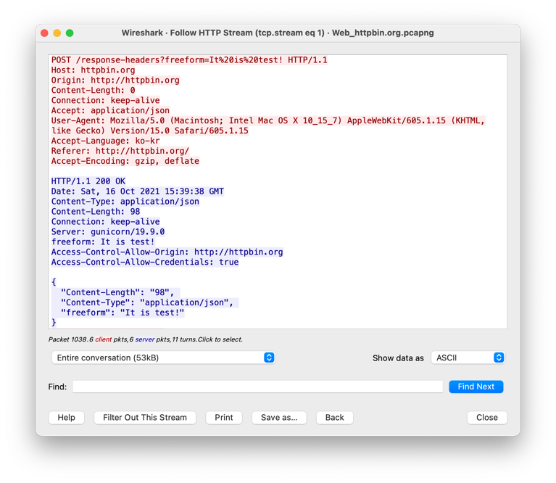

{

"Content-Length": "98",

"Content-Type":"application/json",

"freeform": "It is test!"

}

Through HTTP Request message :

1. Using POST method to send input data. The input data is sent in the URL  
   (/response-header?freeform=[data]) with from of Query not in entity body.
2. The input data type is applicaiont/json
3. The input data is “It%20is%20test! -> It is test!”

Through HTTP Response message :

1. State code : 200 -> it means OK.
2. Response data type is application/json
3. Response data body’s length : 98
4. Response data is right one.
5. ***Get image data (png)***

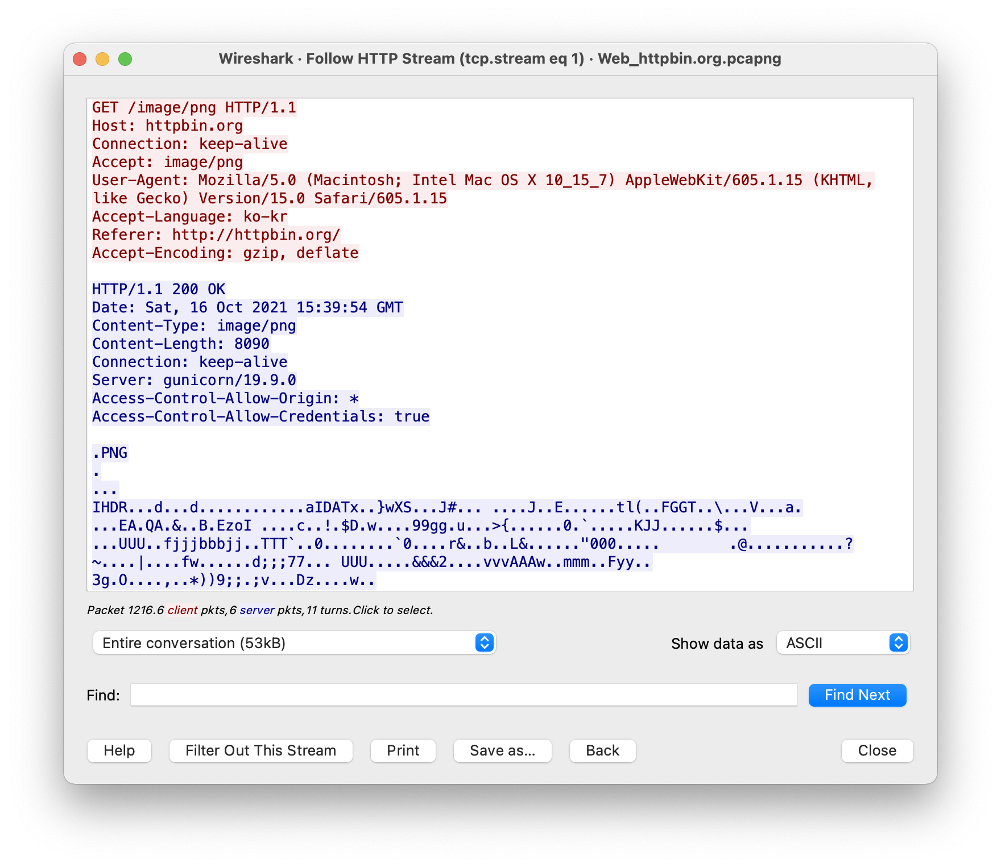

Through HTTP Request message :

1. Using GET method to request image.
2. Request data type is image/png

Through HTTP Response message :

1. State code : 200 -> it means OK.
2. Response data type is image/png
3. Response data body’s length : 8090
4. Response data is right image
5. ***Get HTTP information***

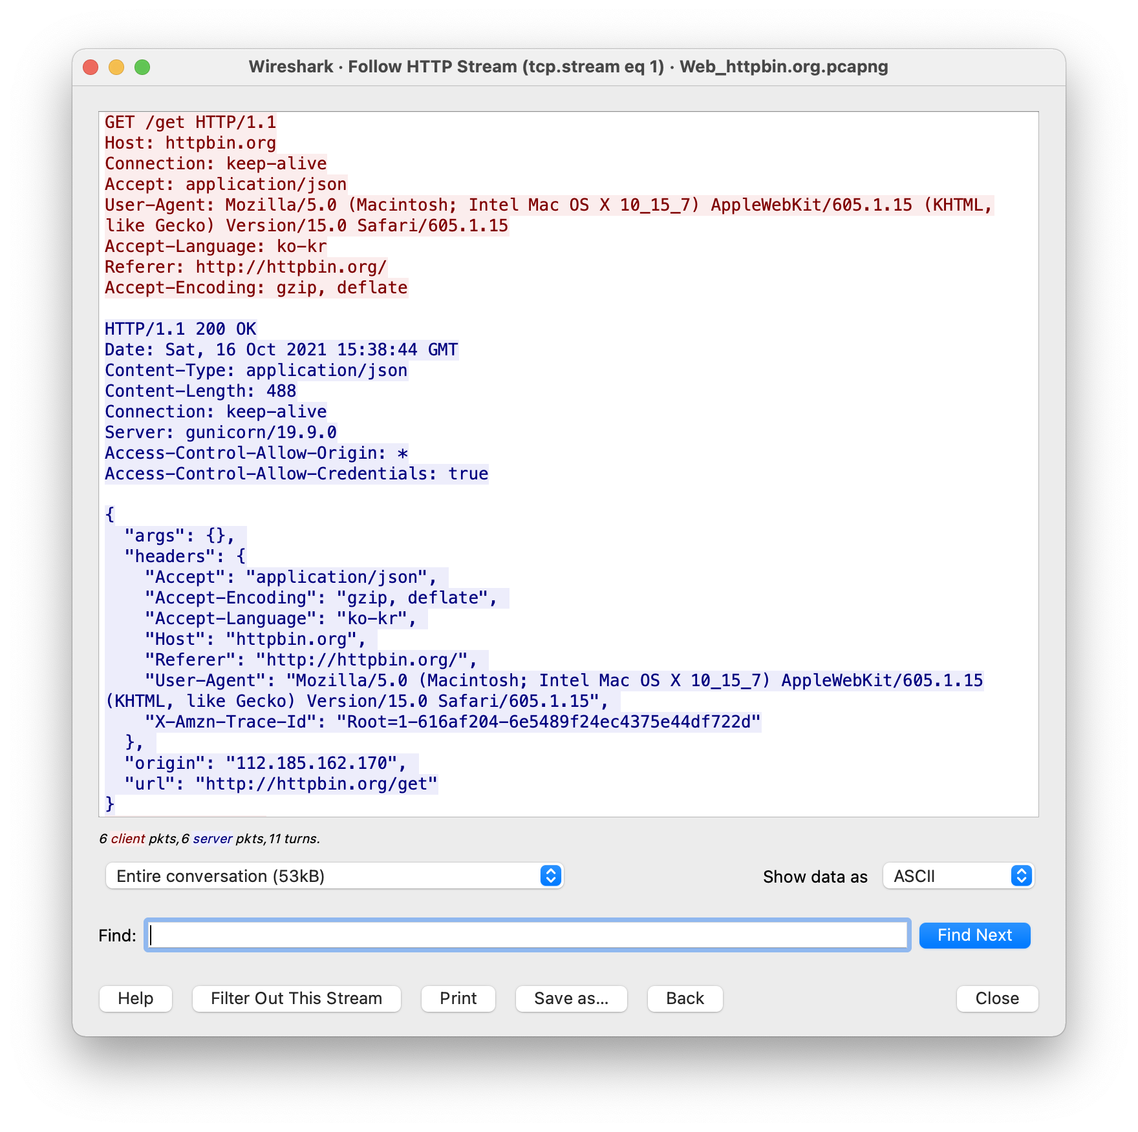

{

"args": {},

"headers": {

"Accept": "application/json",

"Accept-Encoding": "gzip, deflate",

"Accept-Language": "en-us",

"Host": "httpbin.org",

"Referer": "http://httpbin.org/",

"User-Agent": "Mozilla/5.0 (Macintosh; Intel Mac OS X 10_15_7) AppleWebKit/605.1.15 (KHTML, like Gecko) Version/15.0 Safari/605.1.15",

"X-Amzn-Trace-Id":  
"Root=1-616af1fb-7239c5ea4bc1dcaf01a0cda7"

},

"origin": "112.185.162.170",

"url": "http://httpbin.org/get"

}

Through HTTP Request message :

1. Using GET method to request   
   HTTP information.
2. Request data type is application/json

Through HTTP Response message :

1. State code : 200 -> it means OK.
2. Response data type is application/json
3. Response data body’s length : 488
4. Response data is right one

**Application 2 [e-mail]**

1. **Outlook**

***How to create traffic?***

: Use ‘outlook’. Search the receiver directory and send mail.

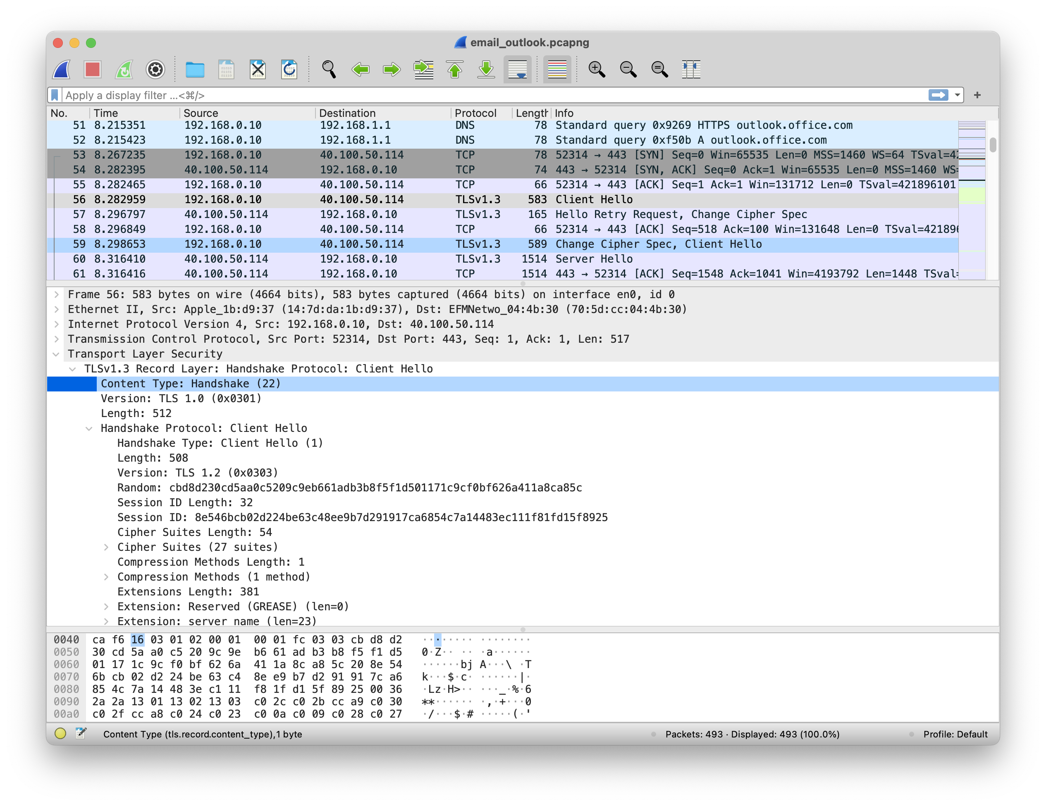

Image is Hand shaking process when searching the receiver directory.

The outlook application is also a client of web email, so I couldn't check SMTP here. To check SMTP, I had to send mail directly.

+) Other info

It use TCP with TLS (security TCP) and TLS version is 1.0. So port num is 443.

1. **Using Telnet & localhost**

***How to create traffic?***

:Use telnet (which is network protocol used to connect to internet or local network) to connect unist domain on port 25. And I sent email. (when I used g-mail domain, access denied because it was treated as spam)

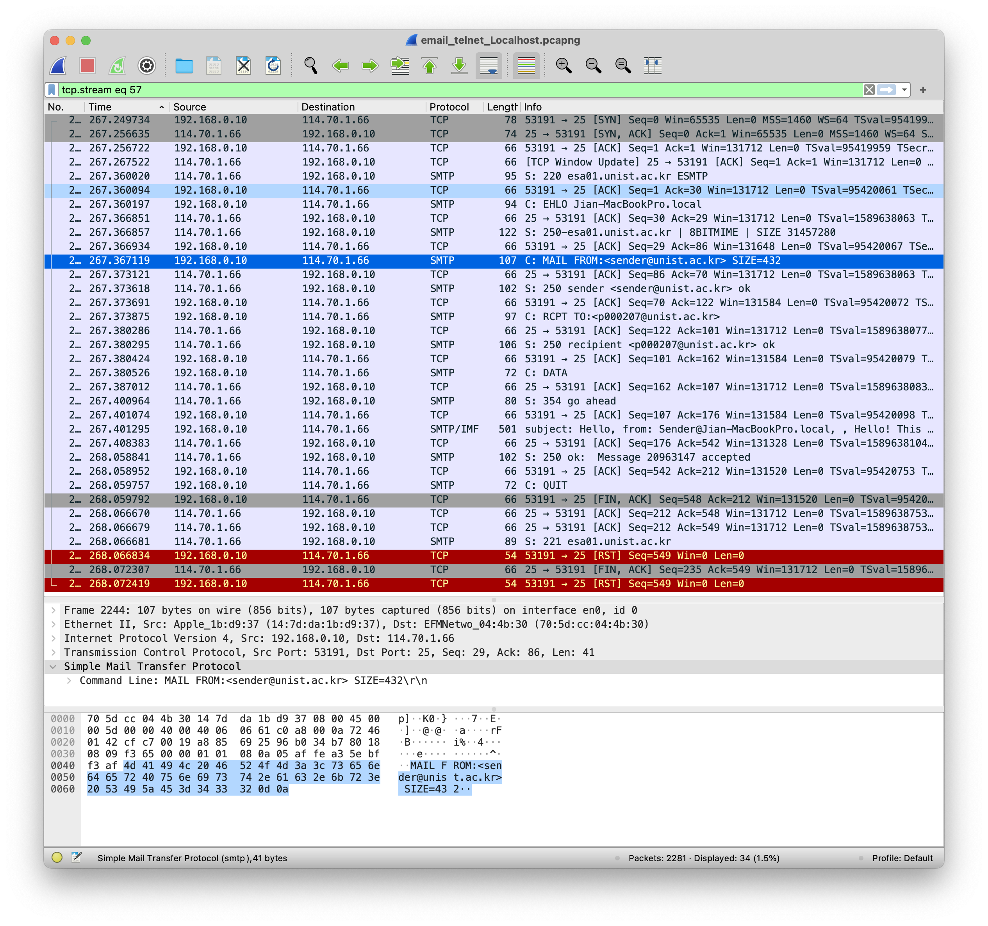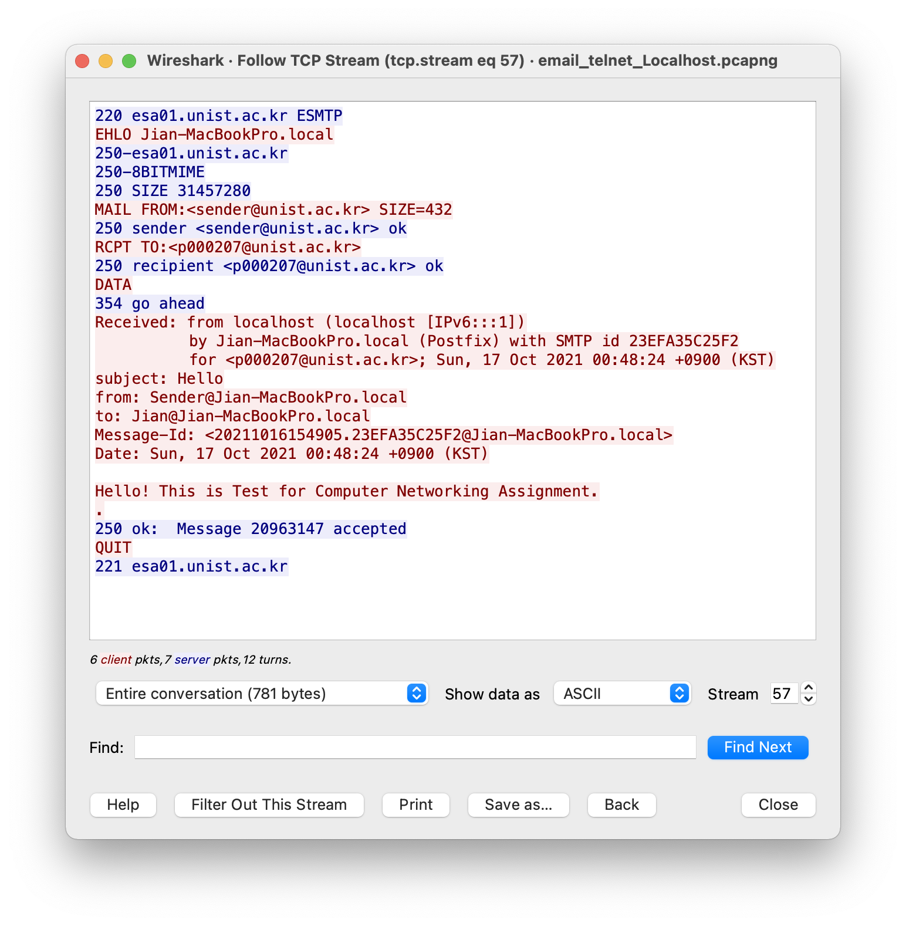

Through this, we can see that SMTP client on port 53191 initiates TCP connection to SMTP server at esa01.unist.ac.kr (unist domain) on port 25. (Send SYN) And SMTP server send SYN+ACK to accepts TCP connection.

Through SMTP message, we can see Mail sending process :

1. Server notification to client that ready to service using state code 220.
2. Client sent EHLO and Host name and SMTP session start.
3. Server notification to client that accepted using state code 250.
4. Client send mail sender / receiver with MAIL FROM / RCPT TO.  
   MAIL FROM:<sender@unist.ac.kr> RCPT TO:<p000207@unist.ac.kr>
5. Server notification to client that accepted using state code 250.
6. Client request to server that client will send data.
7. Server notification to client that accepted request so send the data, using code 354
8. Client send data (subject, mail body ect.)

Received: from localhost (localhost [IPv6:::1])

by Jian-MacBookPro.local (Postfix) with SMTP id 23EFA35C25F2

for <p000207@unist.ac.kr>; Sun, 17 Oct 2021 00:48:24 +0900 (KST)

subject: Hello

from: Sender@Jian-MacBookPro.local

to: Jian@Jian-MacBookPro.local

Message-Id: 20211016154905.23EFA35C25F2@Jian-MacBookPro.local

Date: Sun, 17 Oct 2021 00:48:24 +0900 (KST)

Hello! This is Test for Computer Networking Assignment.

.

1. Server notification to client that mail has been sent successfully using 250.
2. Client request to server that finish connection usint ‘QUIT’.
3. Server notification to client that accepted using state code 211.
4. TCP Connection is finish (FIN/ACK)

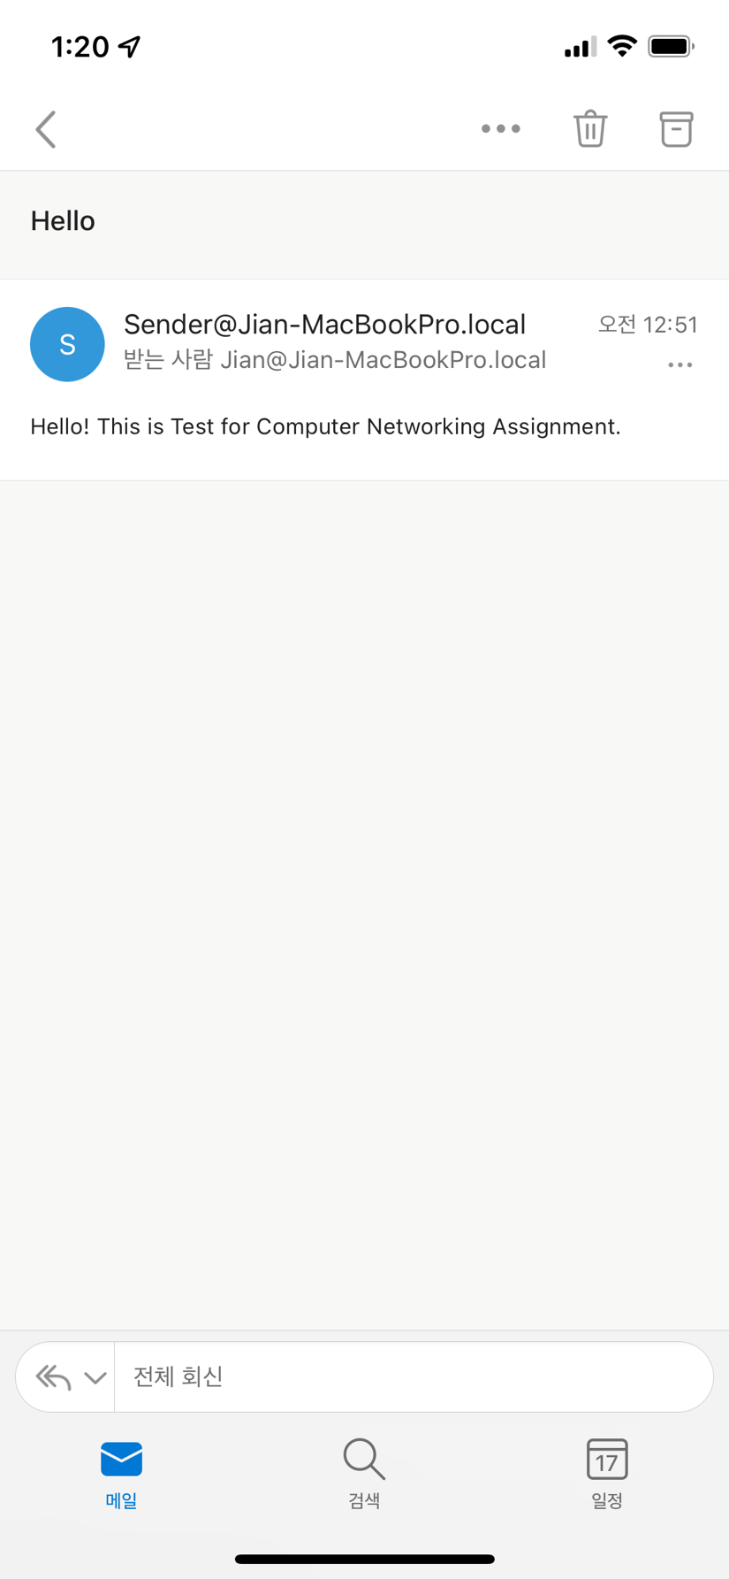 This is the actual mail I sent using SMTP

**Application 3 [DNS]**

***How to create traffic?***

: Go tohttp://google.com not https://www.google.com/. And I used KT DNS.

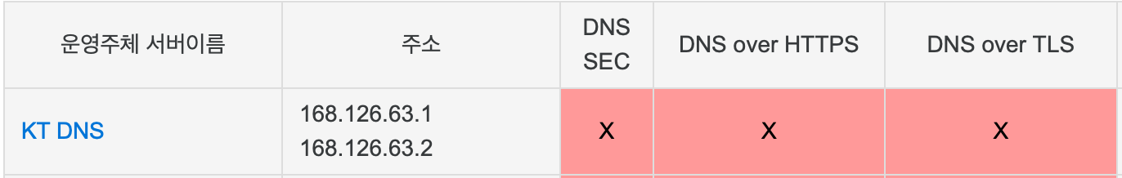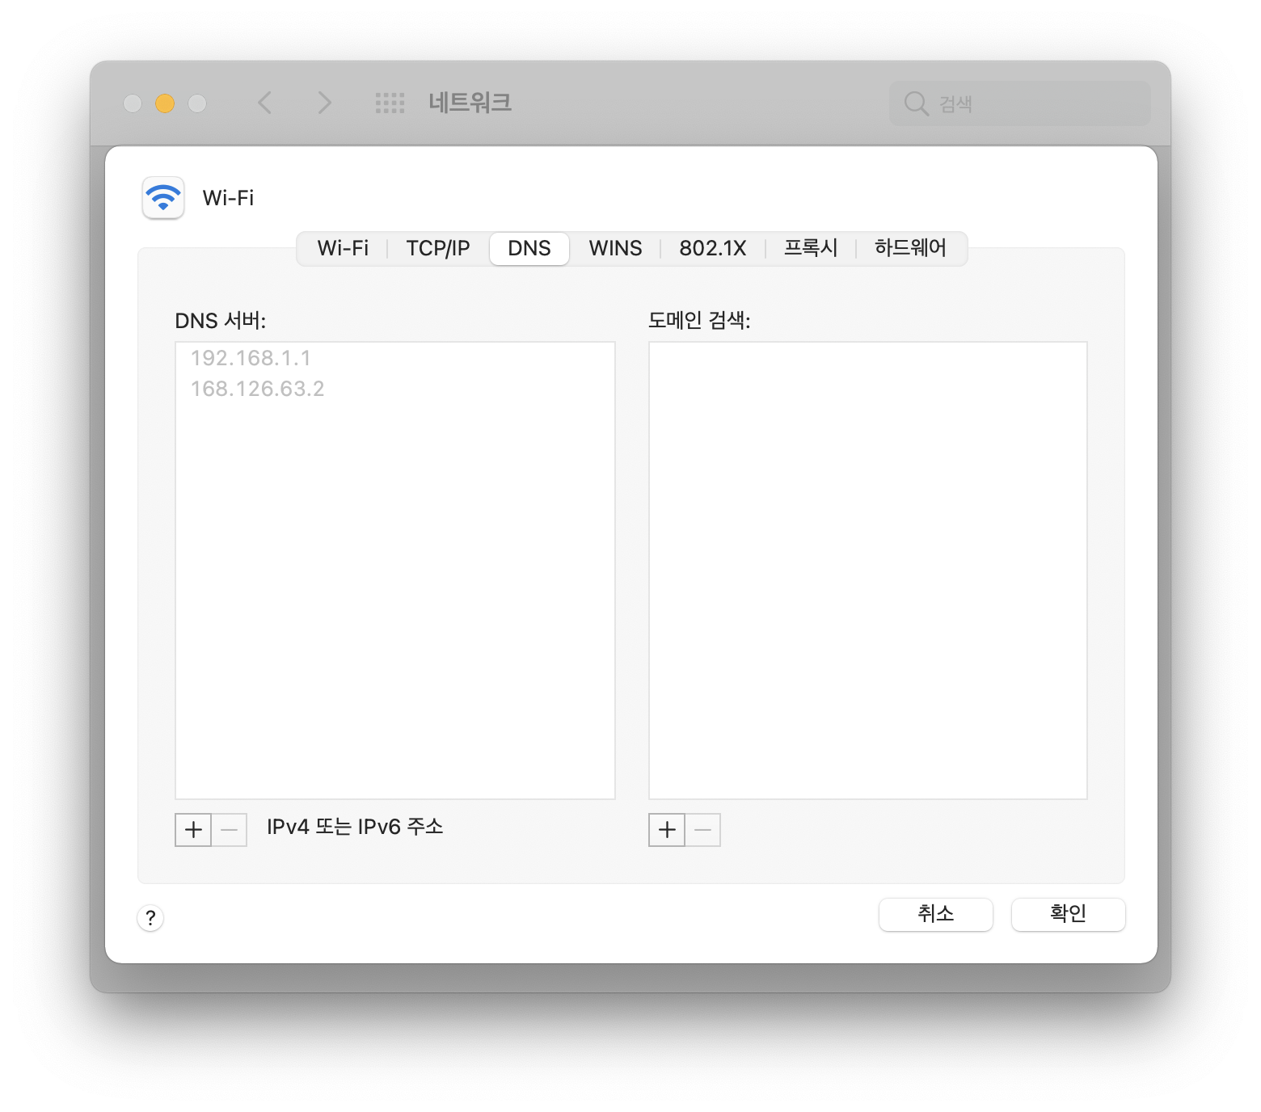



This is DNS query and DNS response. The Type of First query / response pair is HTTPS. Second one is A.

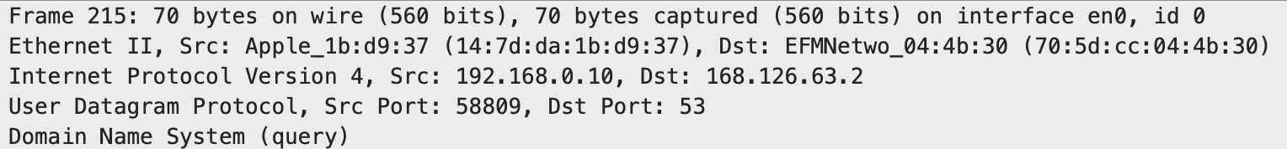

Through this, we can see that DNS is use UDP. And src’s port number is 58809, dst’s port number is 53 (DNS port)

This is DNS query packet. We can see each type, class and other information.

|  |  |
| --- | --- |
| identification = e3 3a | Flags = 01 00 |
| # questions = 00 01 | # answer RRs = 00 00 |
| # authority RRs = 00 00 | # additional RRS = 00 00 |
| questions = google.com | |

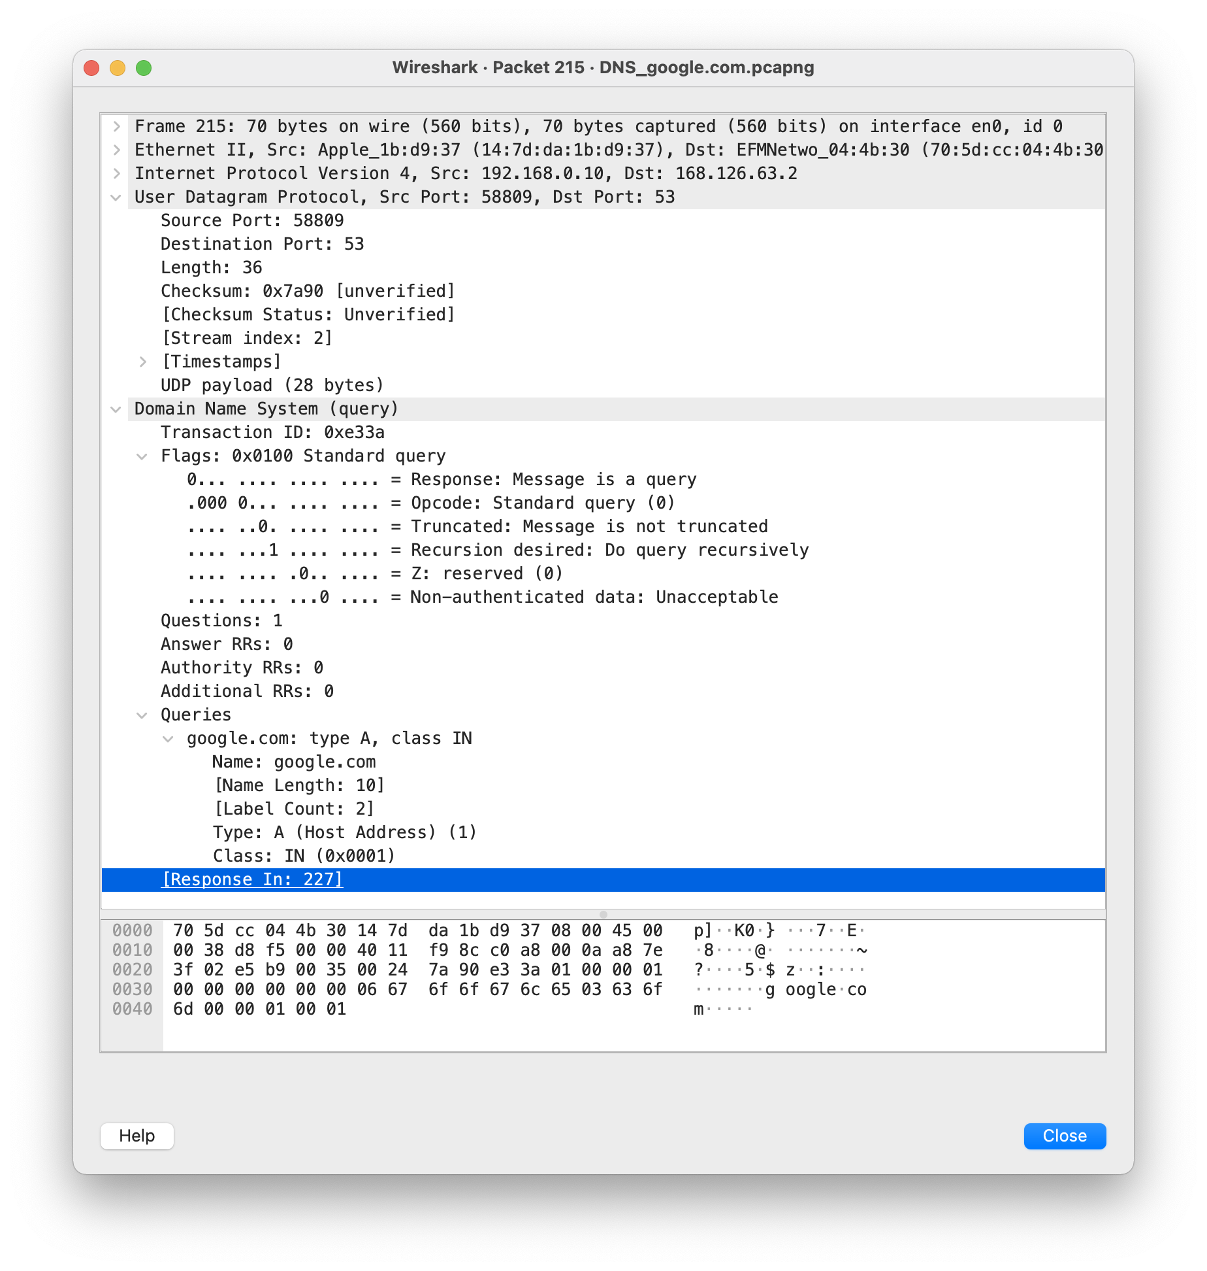

This is DNS query response packet. We can also see each type, class and other information.

|  |  |
| --- | --- |
| identification = e3 3a | Flags = 81 80 |
| # questions = 00 01 | # answer RRs = 00 01 |
| # authority RRs = 00 04 | # additional RRS = 00 08 |
| questions = google.com | |
|  | |
|  | |
|  | |

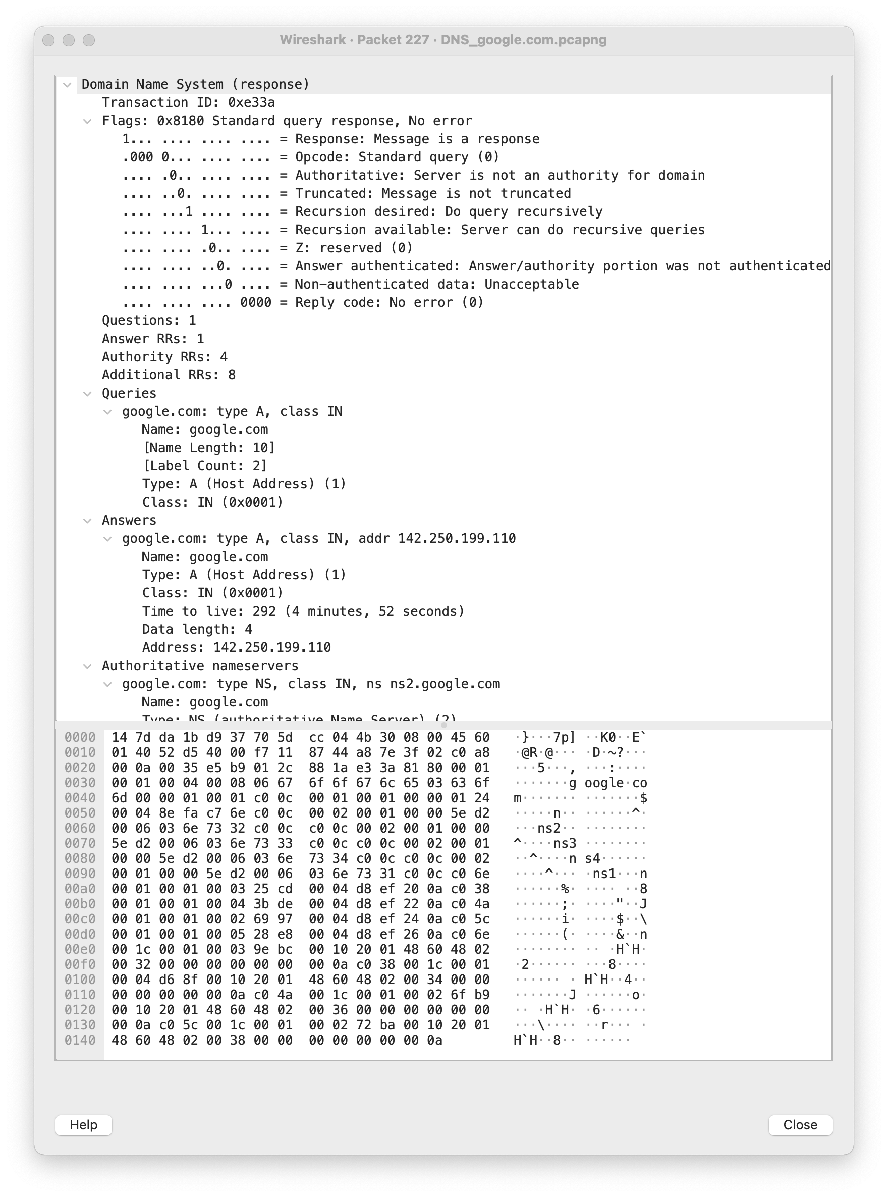

So we can know ip address of [www.google.com](http://www.google.com) and name server of google.com

**Application 4 [Network Games]**

***How to create traffic?***

:Install the car racing game ‘Asphalt 9’. I logged in through my apple ID and saved information about the game through Apple's game center. Also, I played the game and played the challenge content provided online.

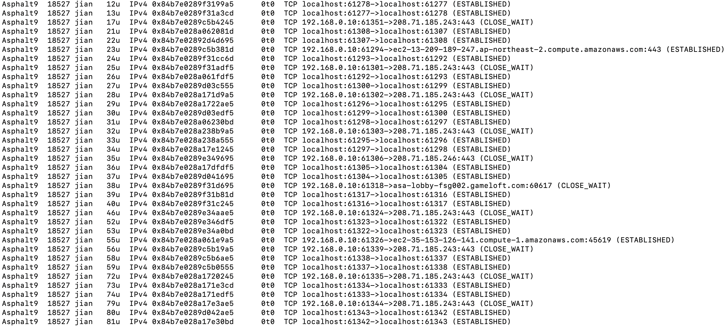

I command the 'lsof-i-P' to find the server address used by ‘Asphalt 9’. Through this, I found that this game uses localhost, gameoft.com (their game company), and Amazon web service (AWS). Ans also found they used TCP.

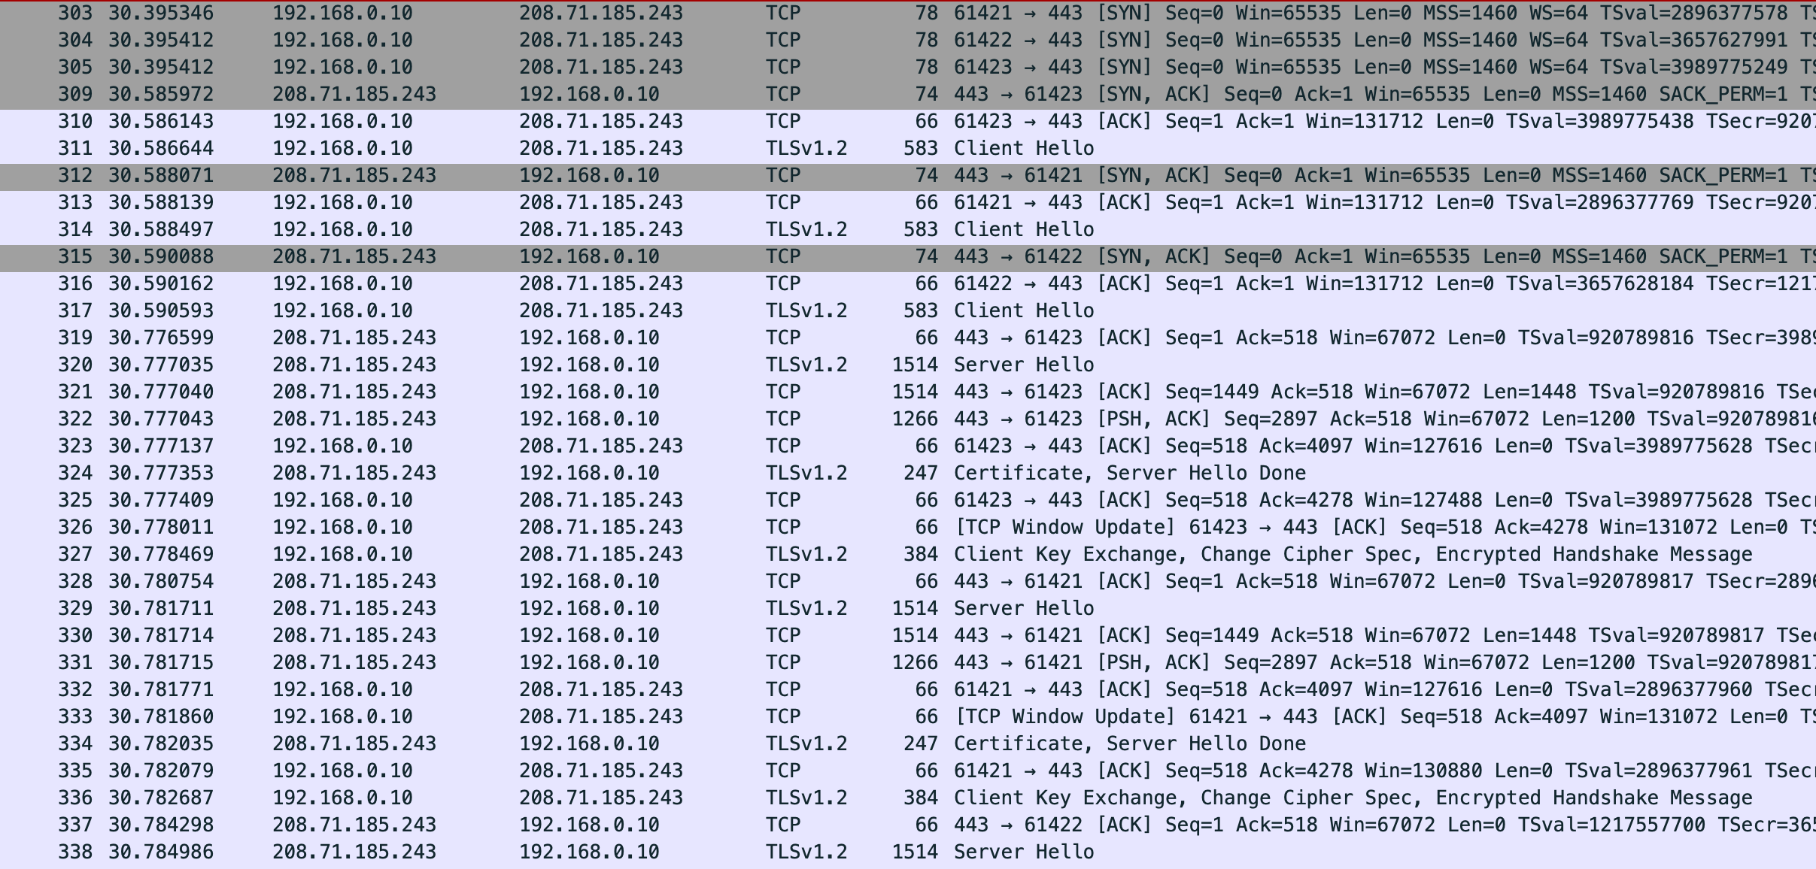

Through picture :

1. we can see that client on port 61421~3 initiates TCP connection to server on port 443. (Send SYN) And server send SYN+ACK to accepts TCP connection.
2. For security, this application use TLS (version 1.2).
3. Three SYNs are continuously requested on different port, and ACK, which is a response to this, is also sequentially received. Through this, it can be assumed that this application connects several communication channels in parallel.

|  |  |
| --- | --- |
| identification = ef fe | Flags = 81 80 |
| # questions = 00 01 | # answer RRs = 00 01 |
| # authority RRs = 00 04 | # additional RRS = 00 07 |
| questions = eve-ap-northeast-2.xsilo-gold.gameloft.com | |
|  | |
|  | |
|  | |

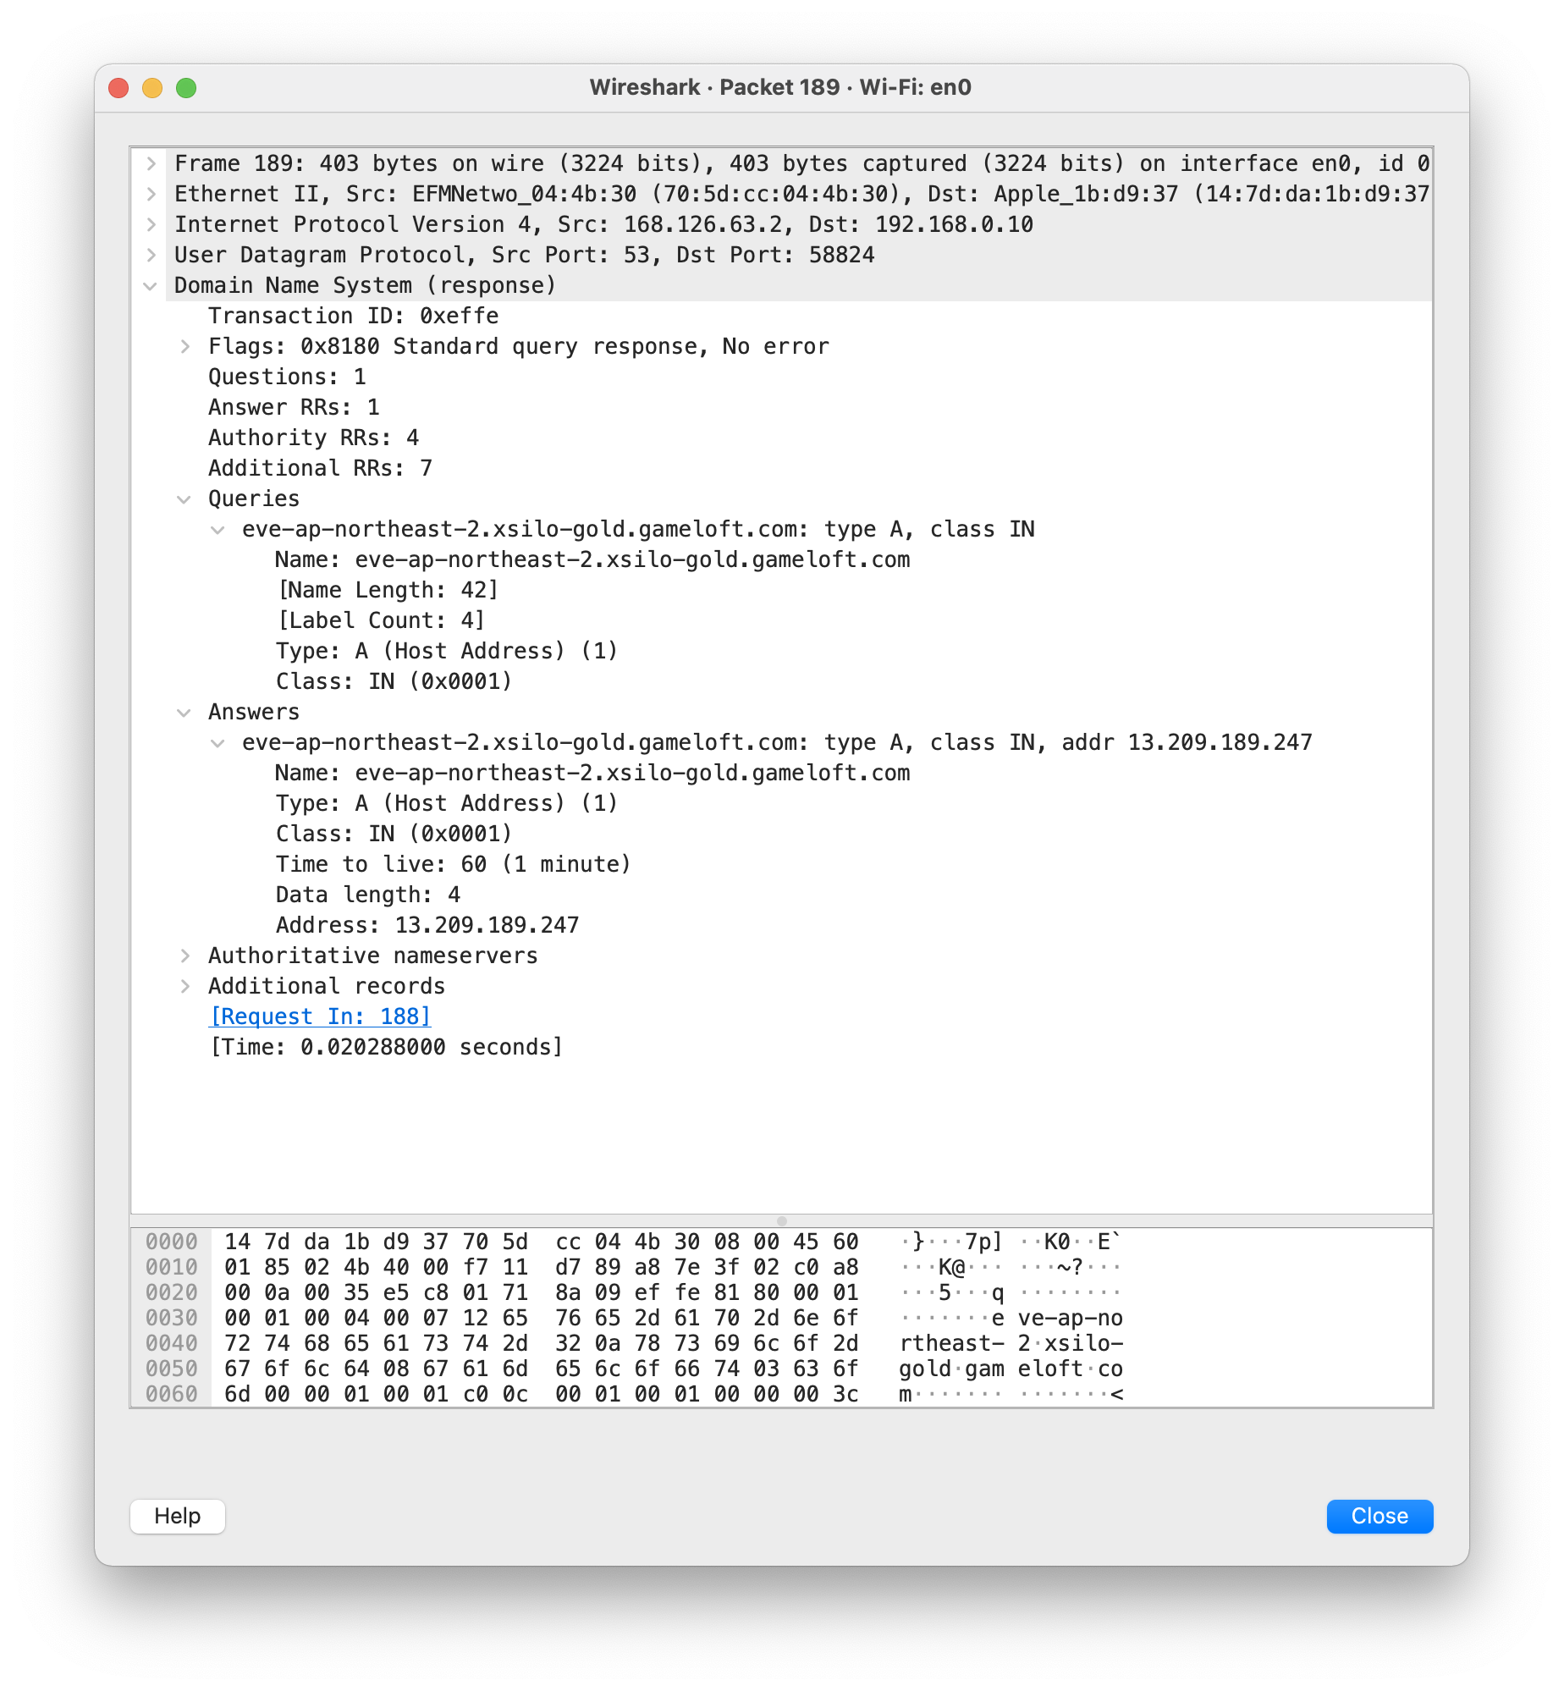

Through DNS response message :

1. This game using AWS to management game data and network service.

+) I can’t understand why packets were communicated to the ip address even after the game was over.

**Application 5 [Video Conferencing]**

***How to create traffic?***

: Use ‘Zoom’ for video conferencing. I access my personal meeting room and use the iPad to access that. And use the camera and voice to make more traffic. Additionally using 'lsof-i-P' command to find the server address. The result is ‘ec2-3-235-73-120.compute-1.amazonaws.com’. (It used AWS too)

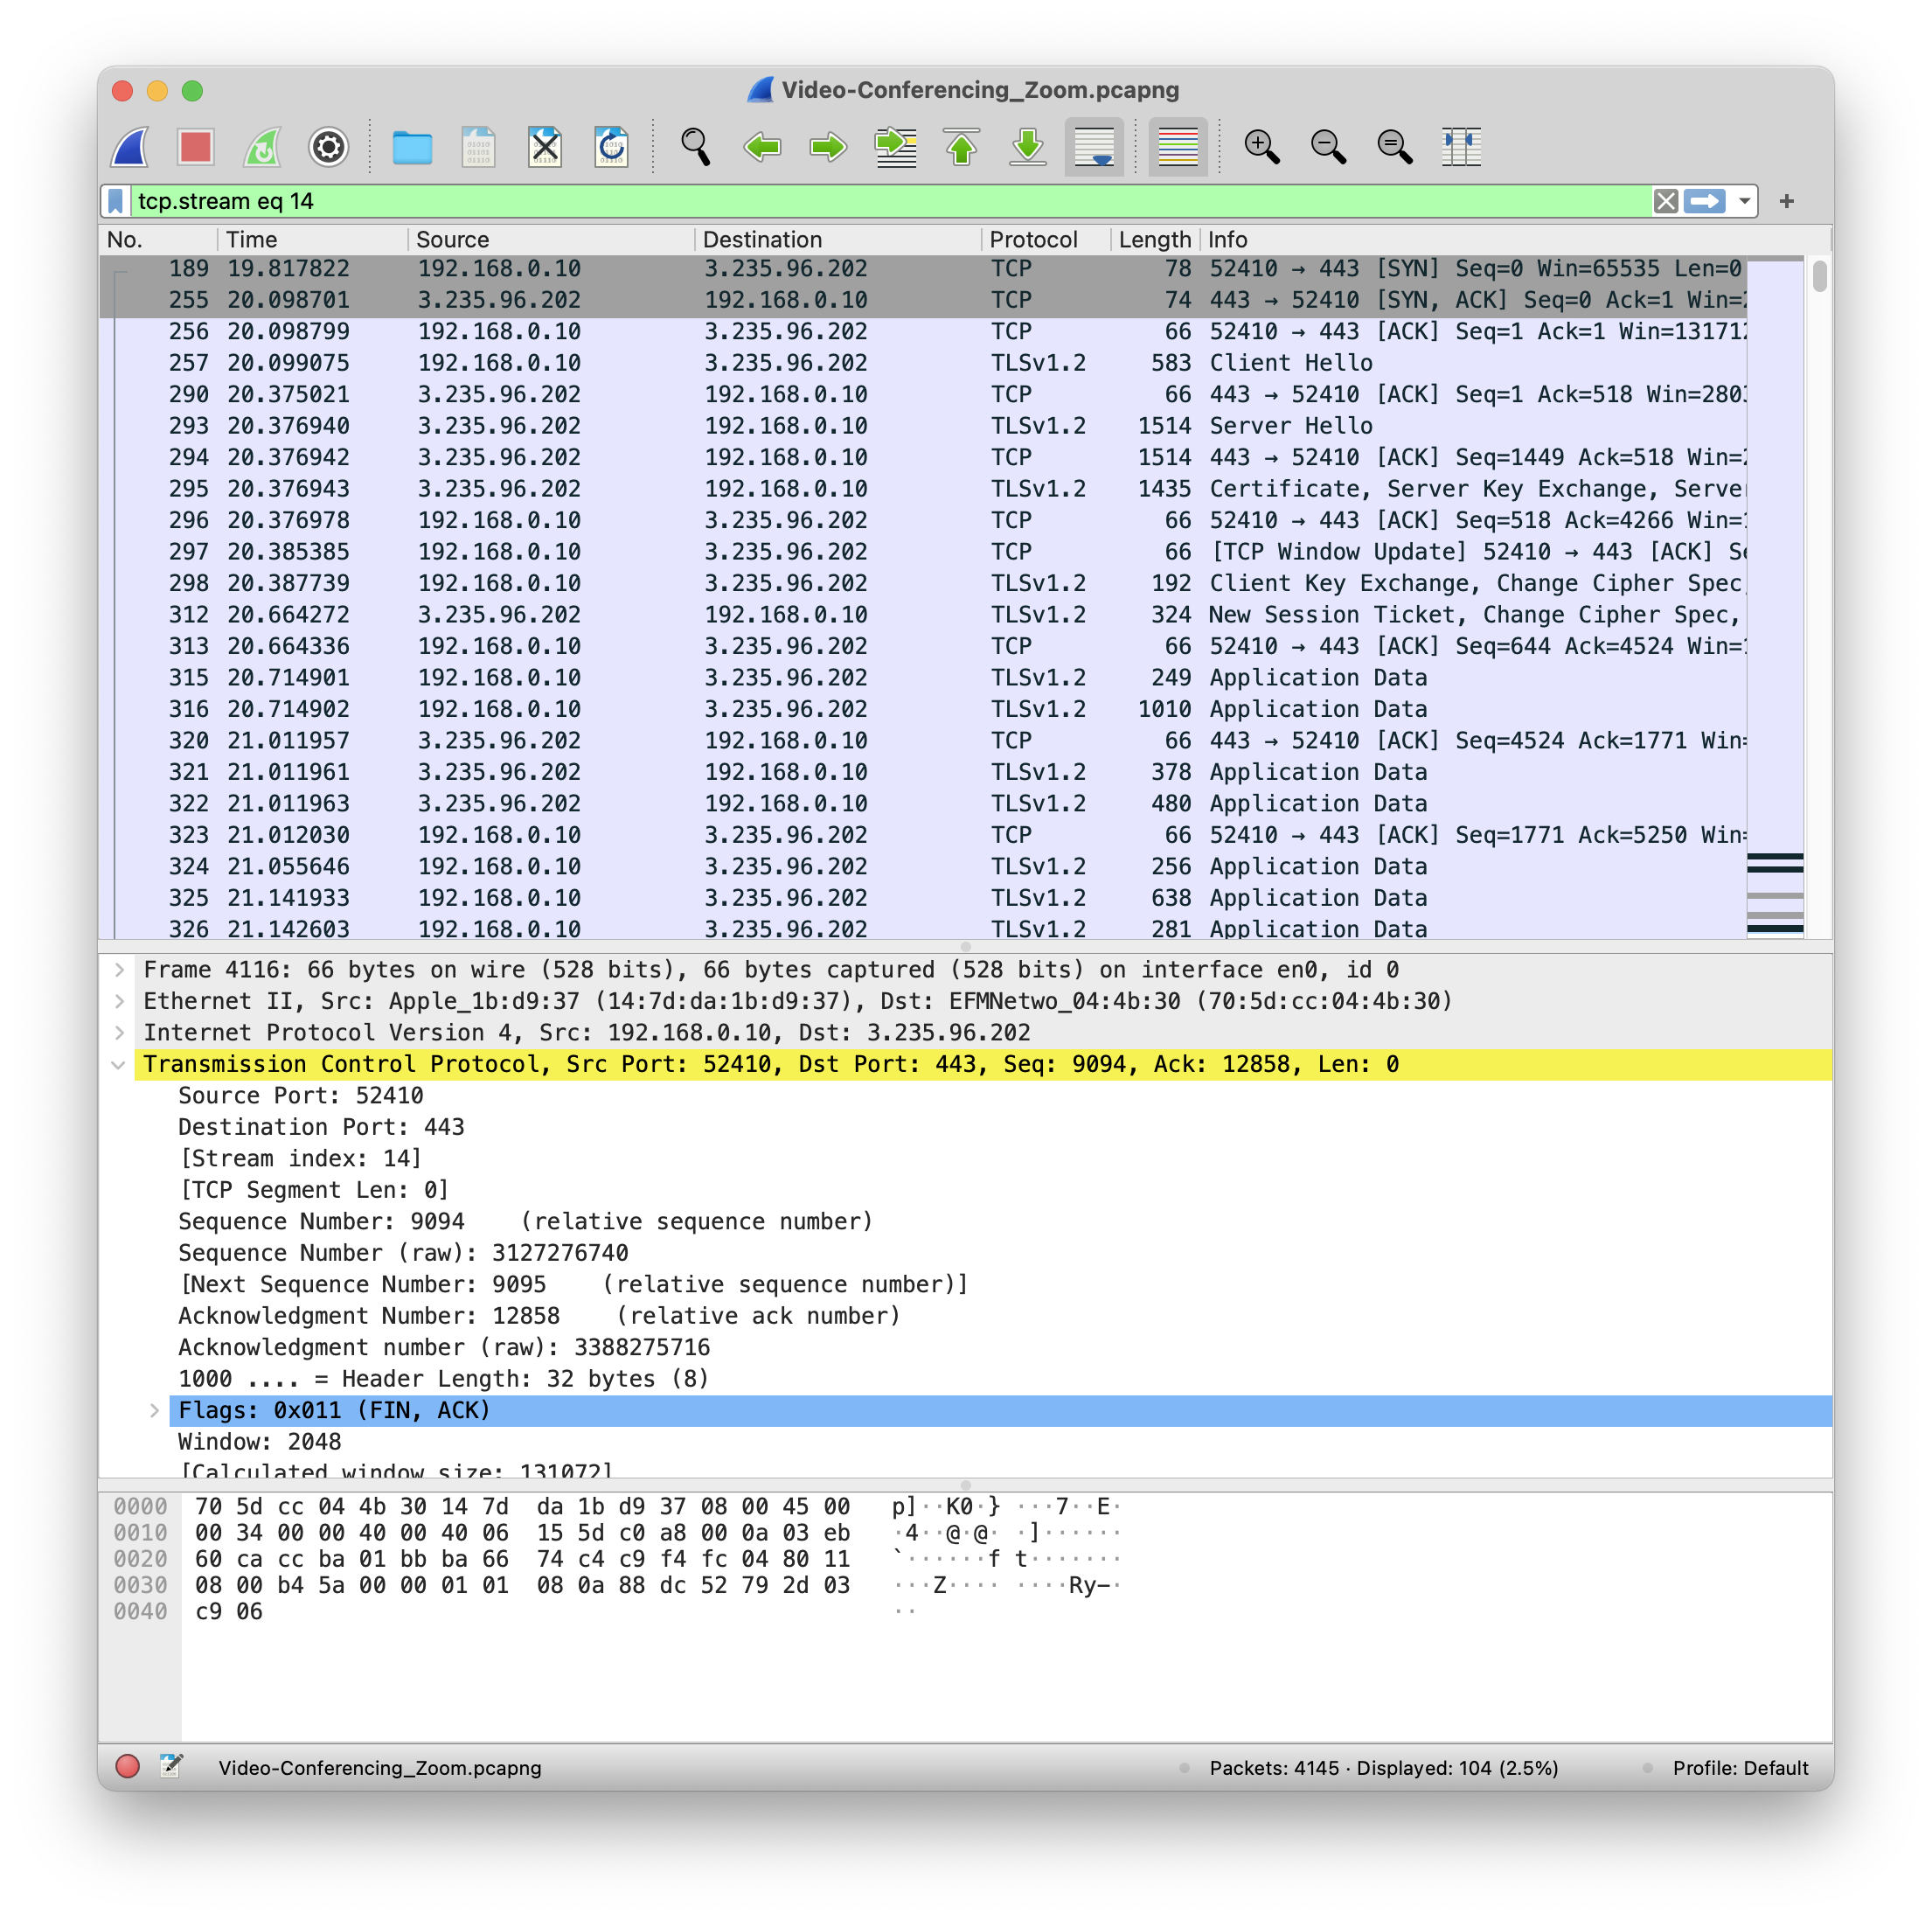

Through this, we can see that client on port 52410 initiates TCP connection to server on port 443. (Send SYN) And server send SYN+ACK to accepts TCP connection. For security, this application use TLS (version 1.0).

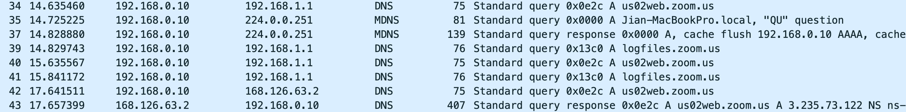

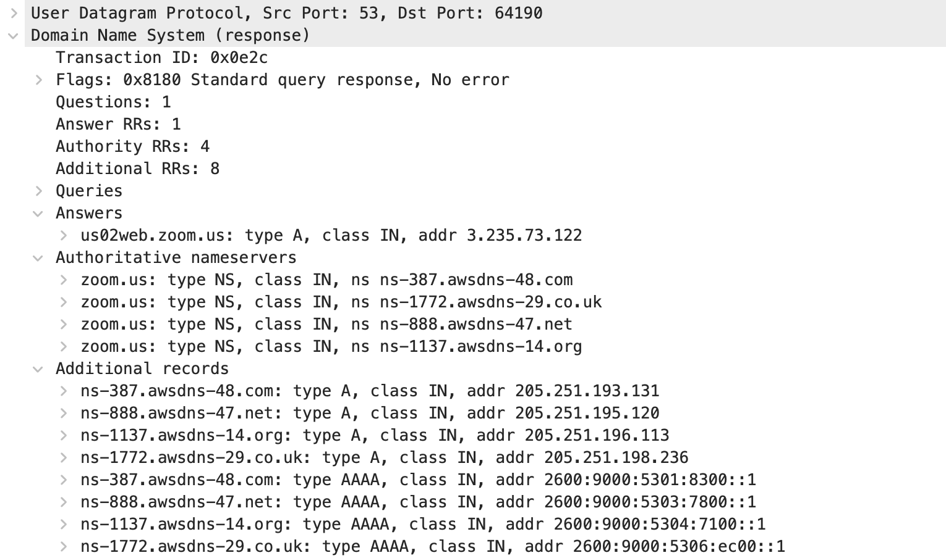

These are DNS query / response messages pairs when I lunched ‘zoom’. Through this ‘zoom’ using AWS to management game data and network service.

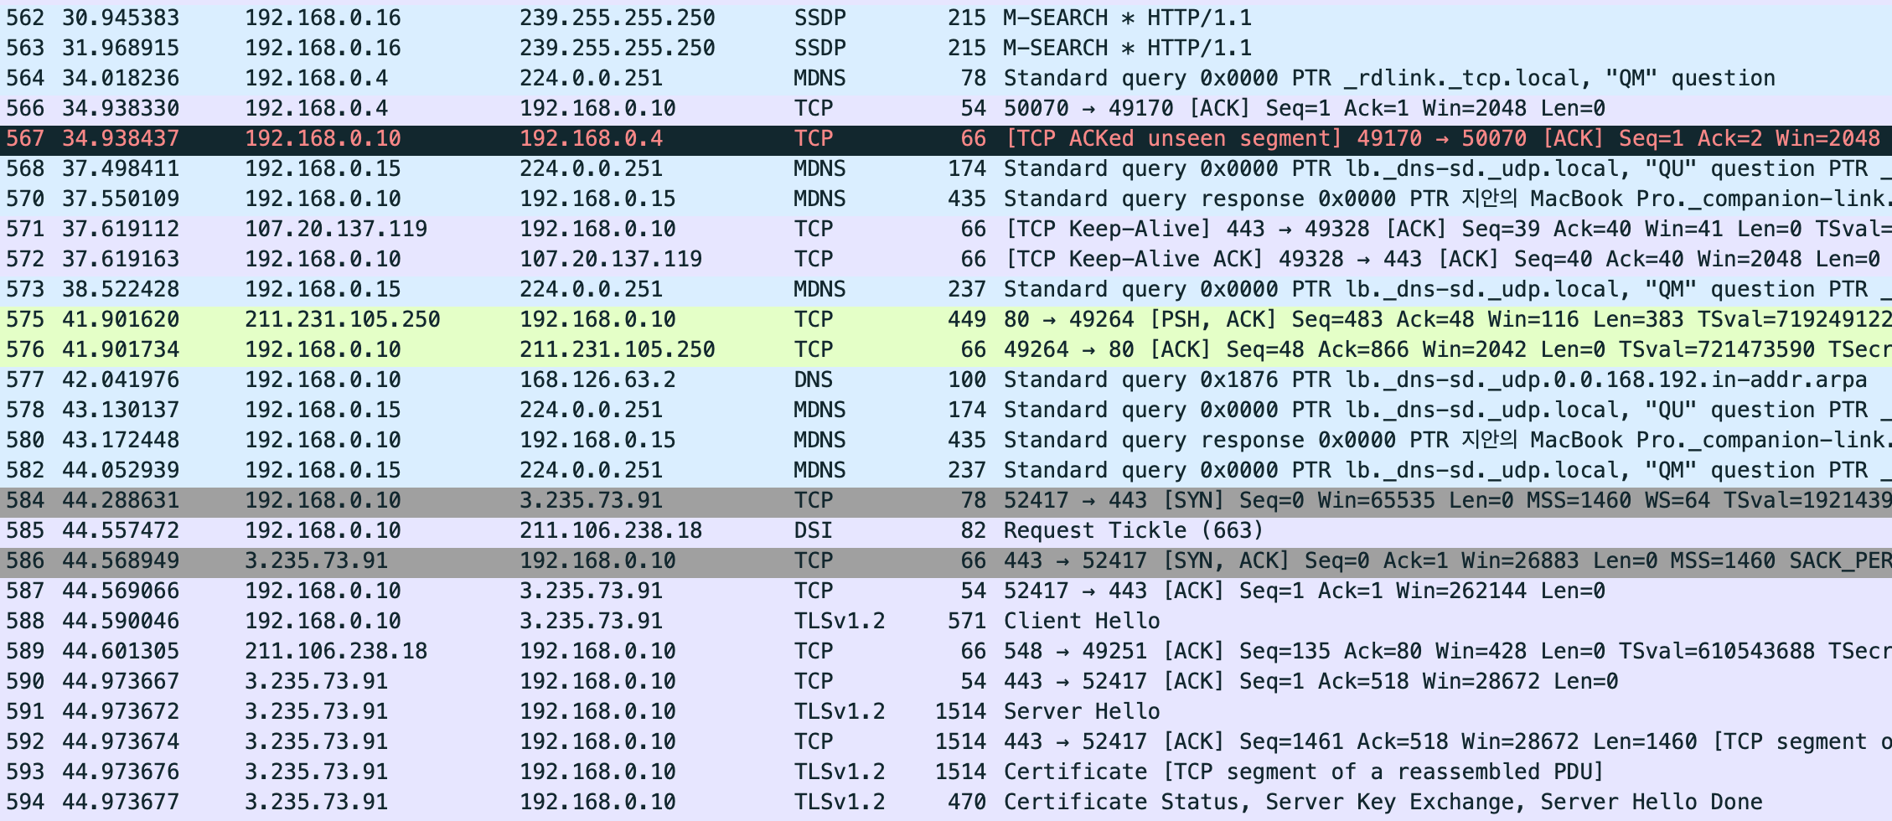

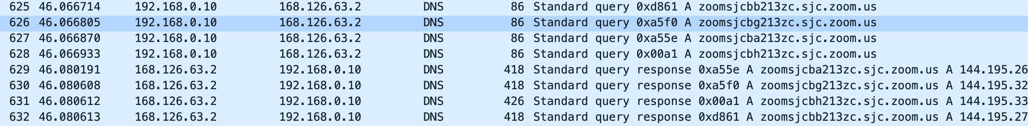

These are the packets after I access my personal meeting room.

**Application 6 [Video Streaming]**

***How to create traffic?***

: Use access <http://watcha.com/>. After accessing, I search keyword ‘Venom’ and played it.

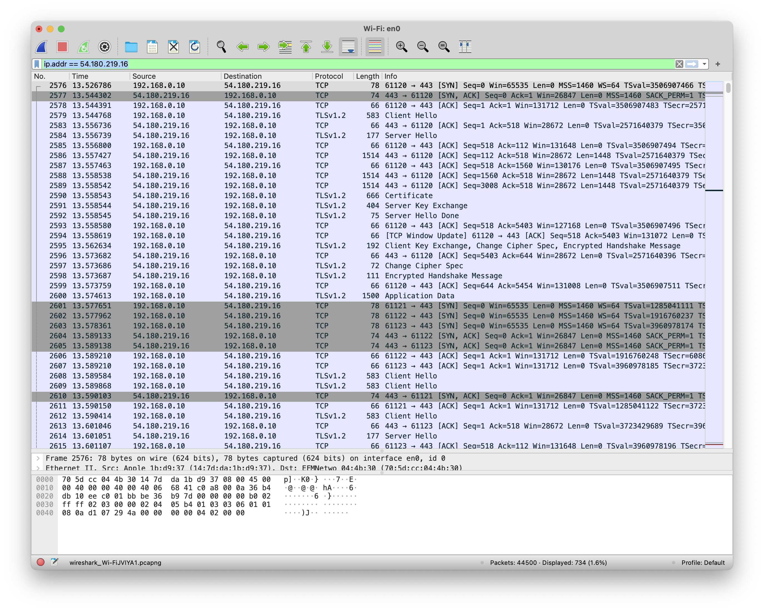

Through this:

1. we can see that client on port 61121~3 initiates TCP connection to server on port 443. (Send SYN) And server send SYN+ACK to accepts TCP connection.
2. For security, this application use TLS (version 1.2).
3. Three SYNs are continuously requested on different port, and ACK, which is a response to this, is also sequentially received. Through this, it can be assumed that this application connects several communication channels in parallel.

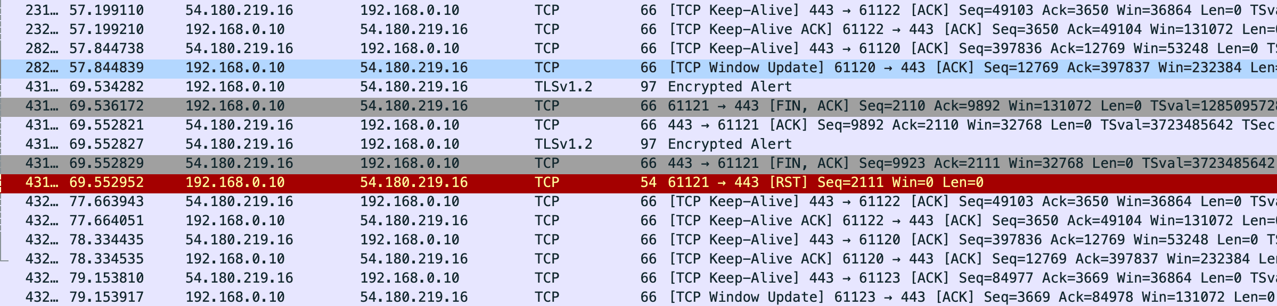

After video play, only keep-alive packets that maintain the tcp connection. I assume it is maintaining the connection.

**Application 7 [Remote Login]**

***How to create traffic?***

: Use ‘Team viewer’ to remotely control my window laptop with my MacBook. After connected Macbook and window laptop. I control cursor and typing. And file(png) transfer MacBook to laptop. ‘Team Viewer’ use port 5938.

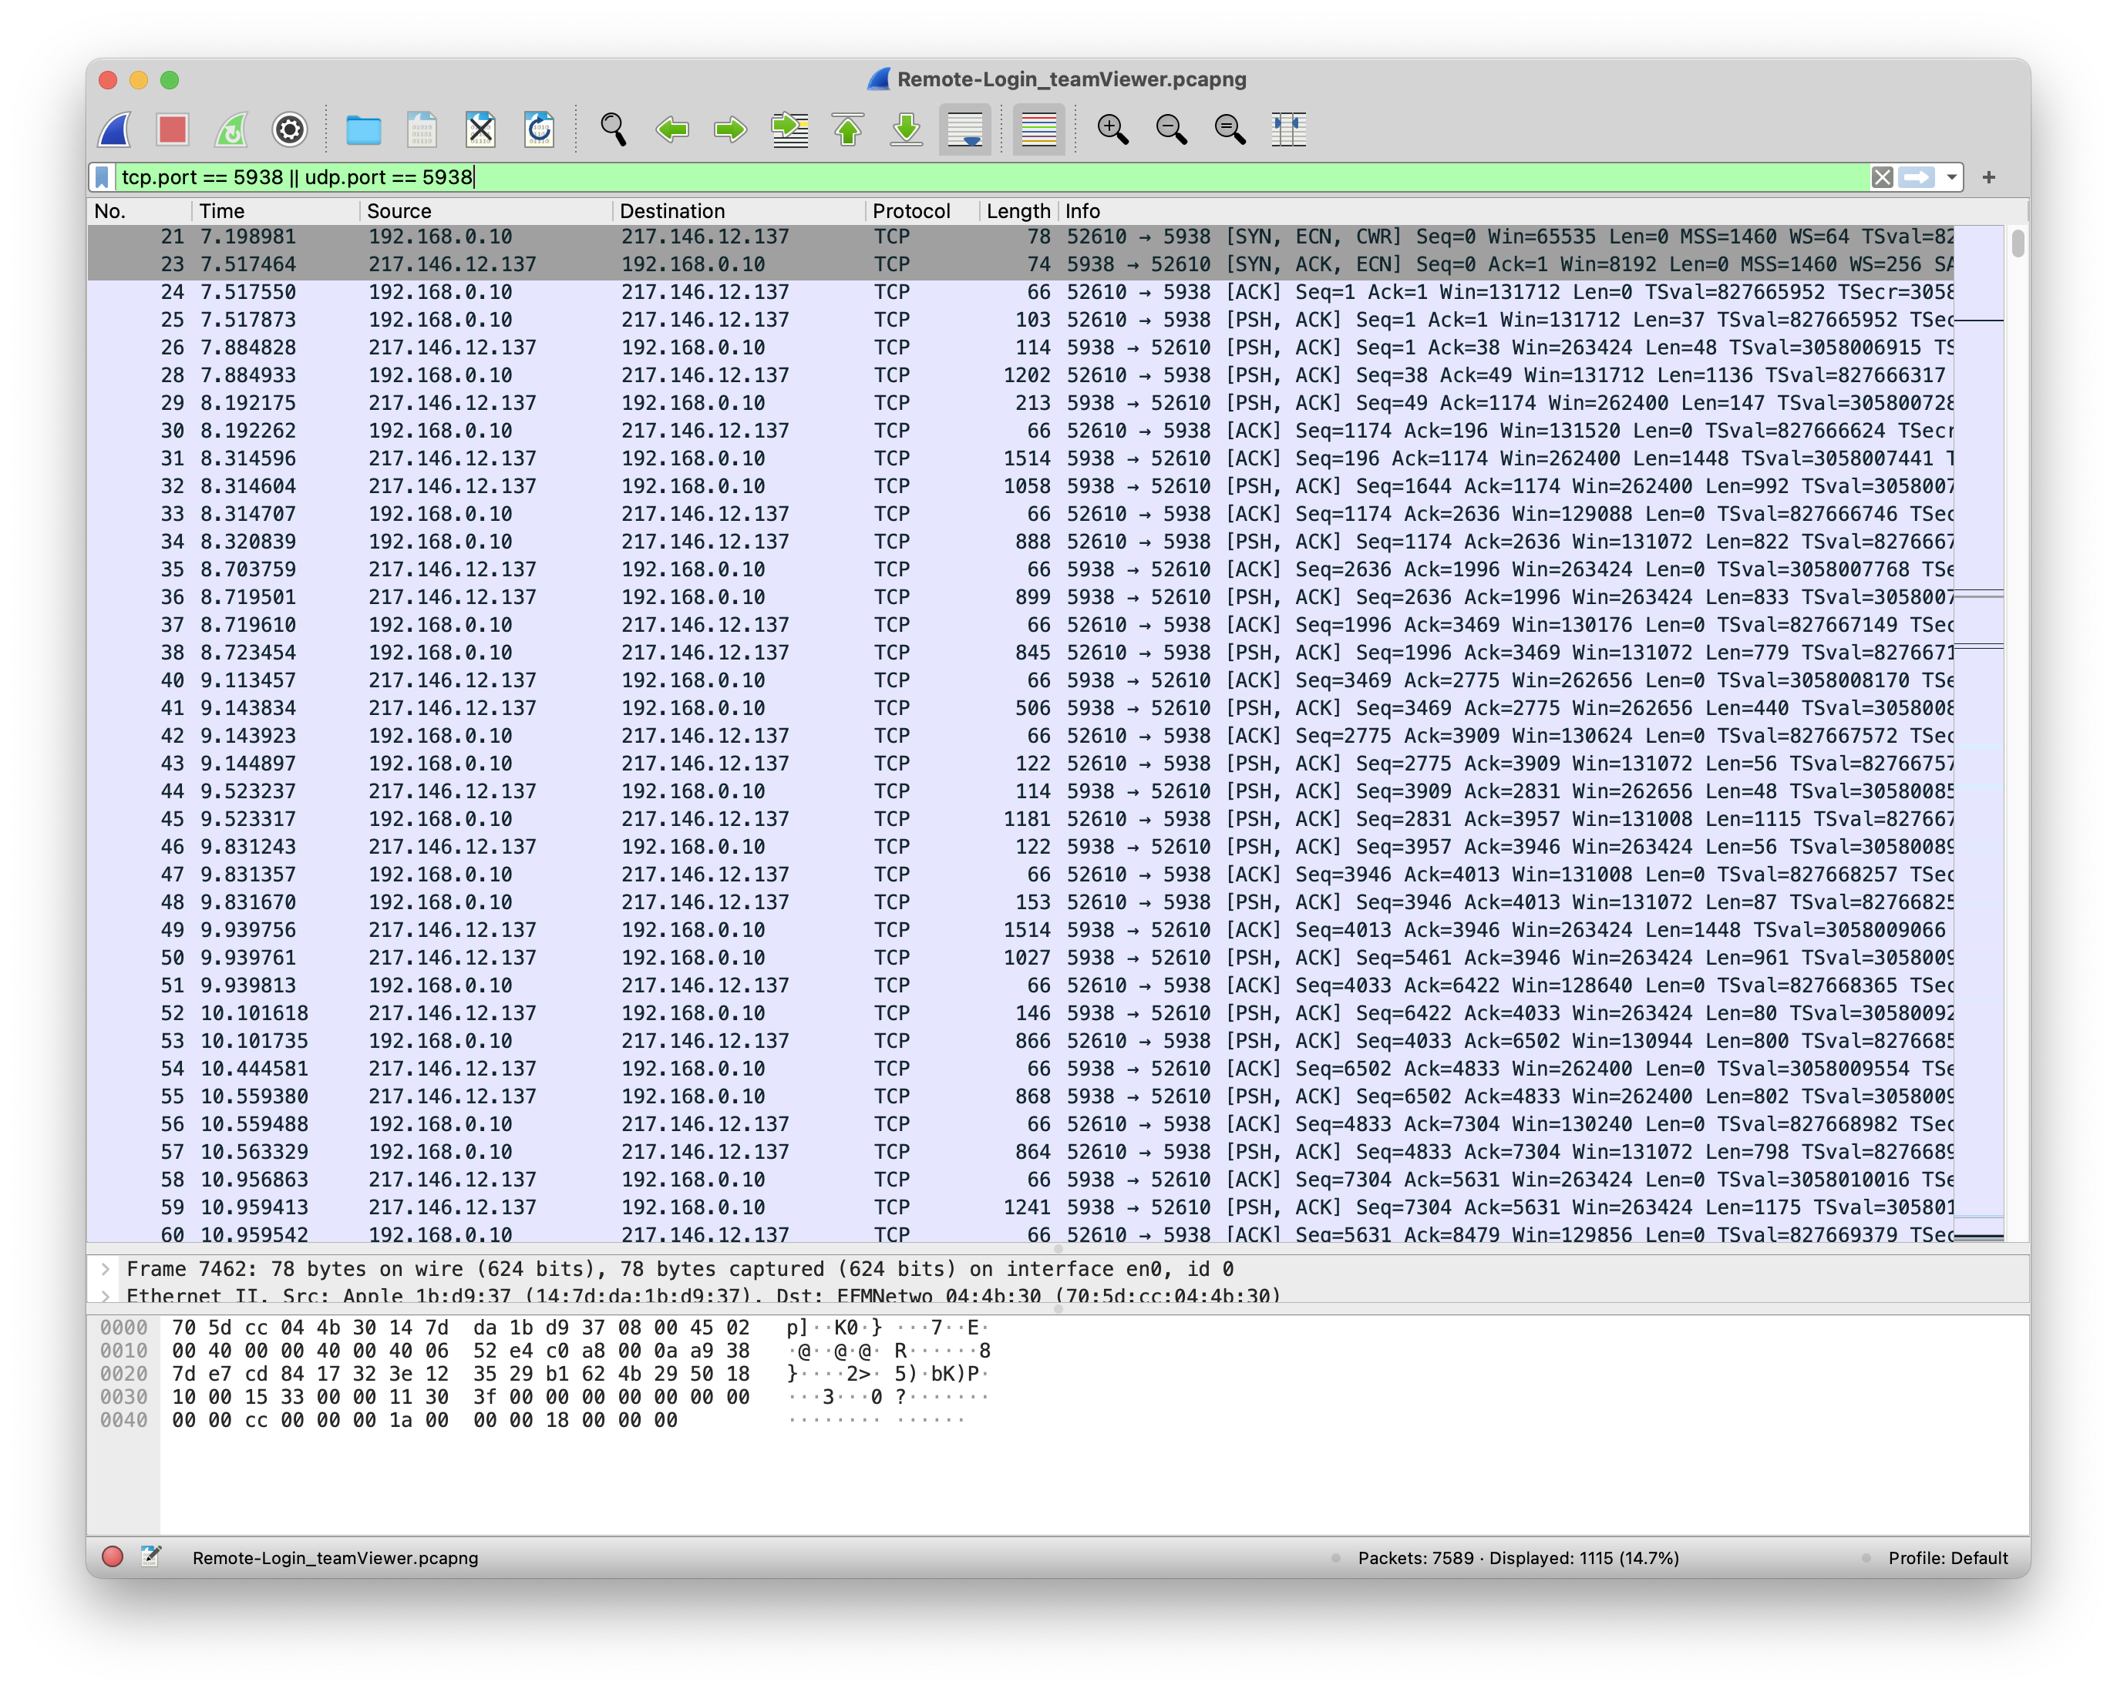

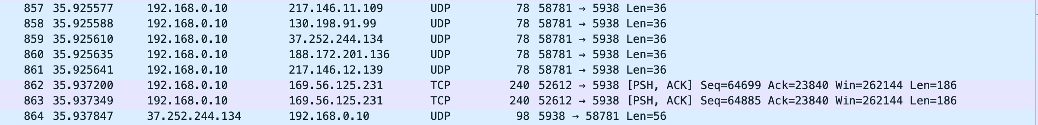

Through this:

1. we can see that client on port 52610 initiates TCP connection to server on 5938. (Send SYN) And server send SYN+ACK to accepts TCP connection.
2. Also use UDP connection too (on port 5938). It is assumed that this is used to speed up the reaction and the importance of 'reliability' is low.
3. Use PSH. It is used to send the TCP segment directly from the sender/receiver side without maintaining it in the buffer. Since it is very sensitive to time, PSH is set when using a user-centered application.

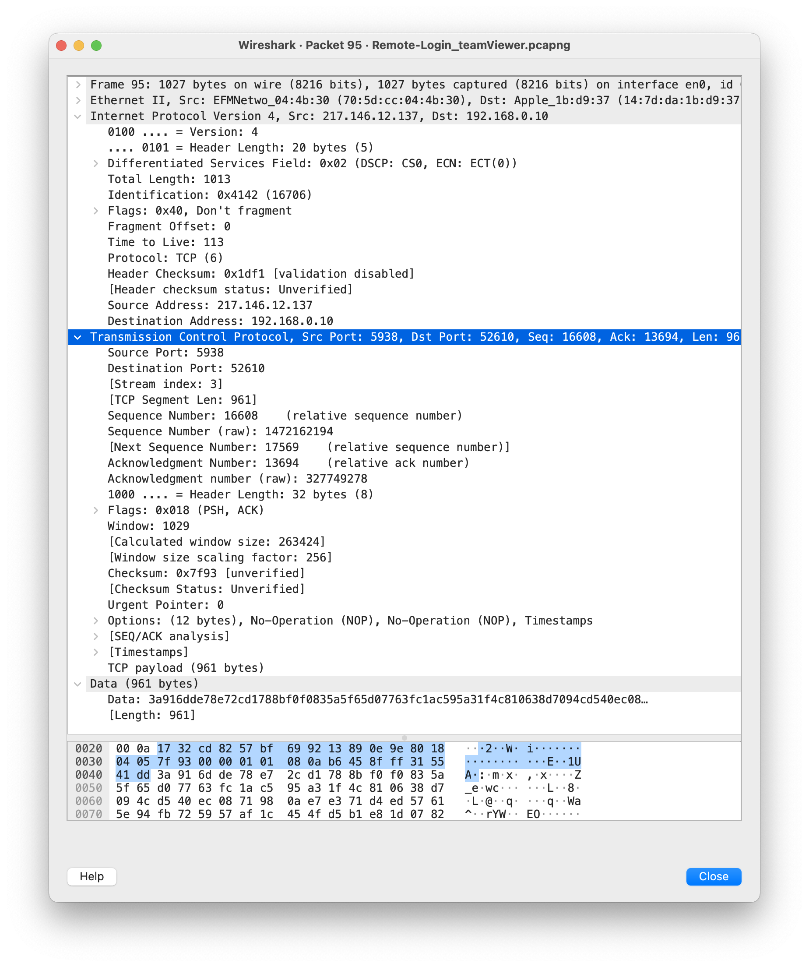

This is TCP response message. Through this, we can see time to live, what use protocol, src, dst port number, TCP sequence number etc.



***This is RTT of TCP***

1 : Lunch ‘Team Viewer’

2 : Remote conneted window laptop

2 ~ 3 : Control window laptop with MacBook (control cursor, typing)

3 ~ : ‘.png’ file transfer MacBook to laptop

4 ~ : Finished remote connetion

5 ~ : ‘Team Viewer’ was over